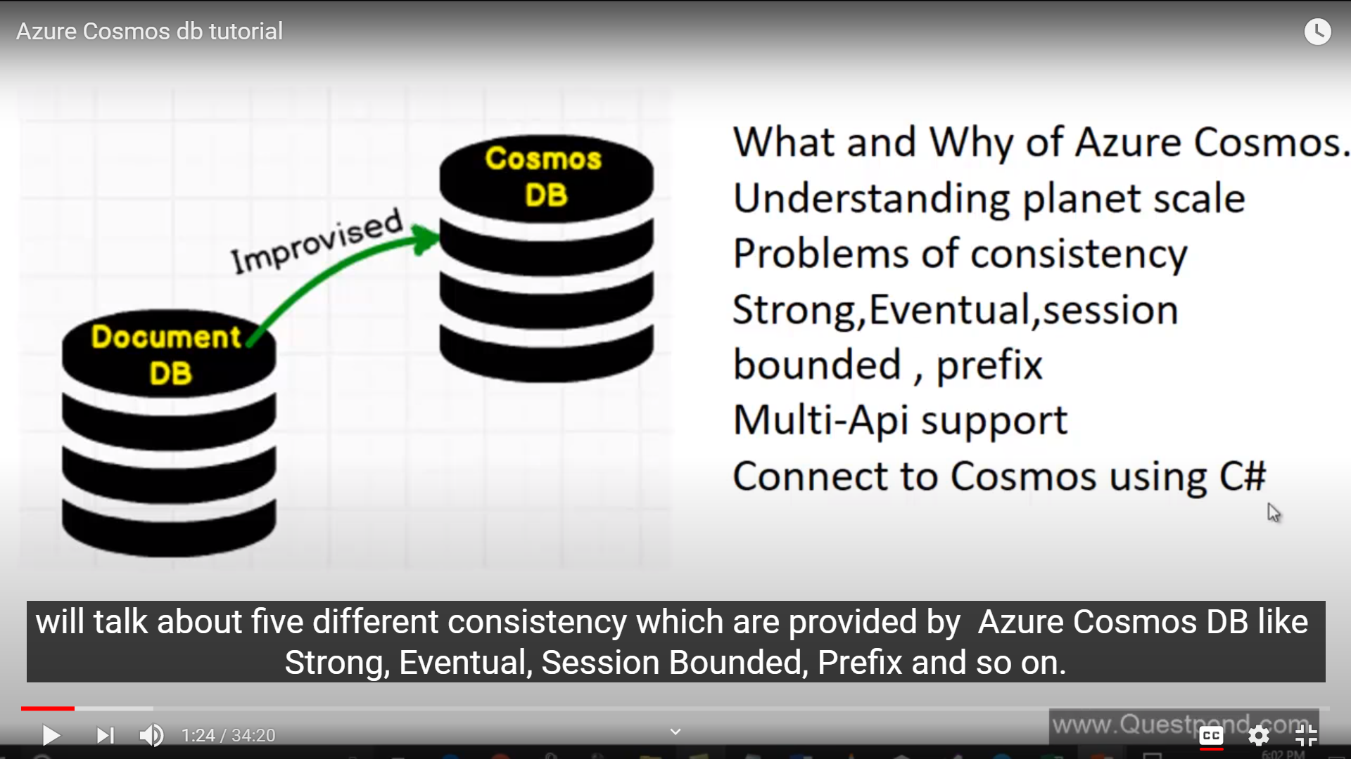

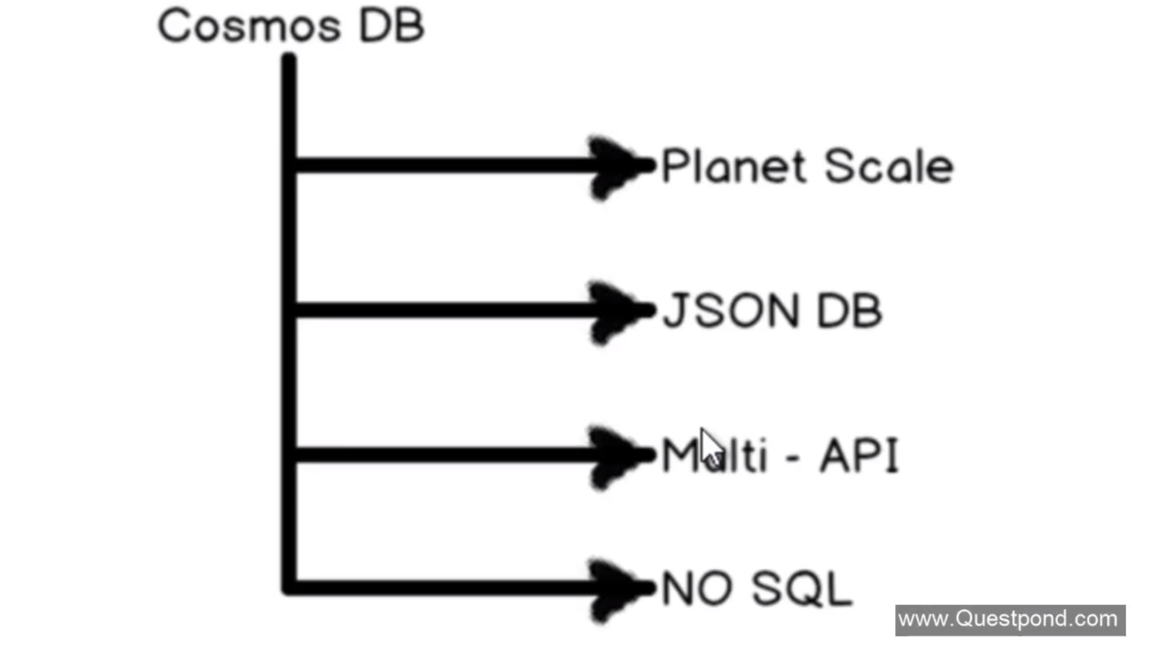

Cosmos DB falls into Planet Scale Database Category

What is Planet Scale

It’s a improvised version of DocumentDB

Cosmos DB is a planet scale no sql json database with multi api support

Cosmos means universe. It intends you to give a planet scale database

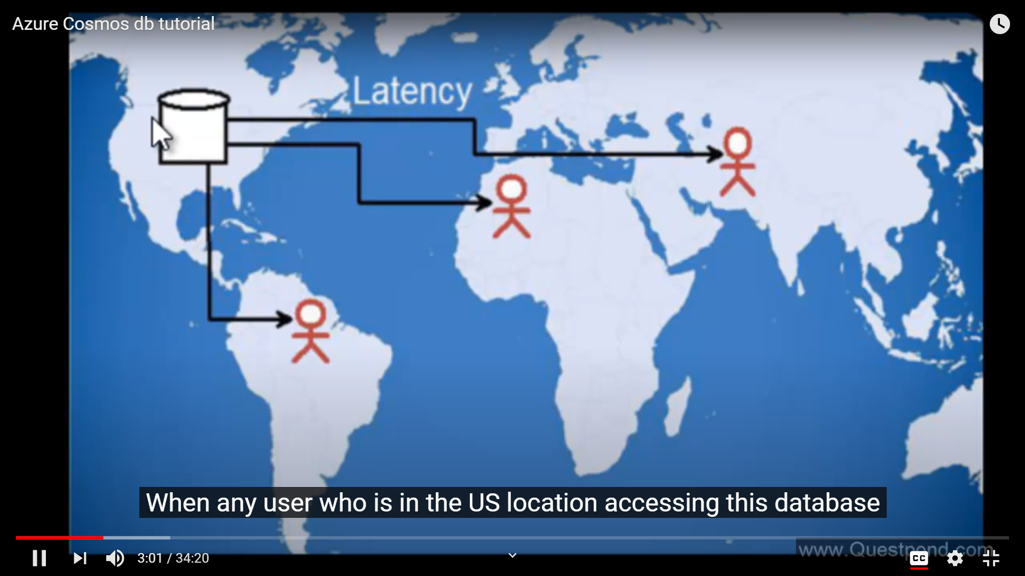

We have a database in US. Users are using it across the geography. People who are close to this region will get faster as compared to others in other geographies. Performance is not same in all the regions. Solution is to bring database near to the end user’s geography.

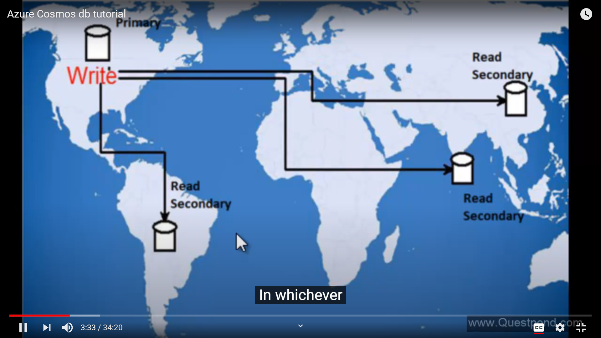

What we will do is that wherever our users are located in geography, we will set up our database there. i.e. Secondary Database or Read database and out Primary or Write database is in US. So whenever user writes in US Region, data is replicated to other Secondary Database.

So the main database where user writes data is k.a. Primary Database and the other databases are k.a. Read Databases.

Now one of the biggest problem to achieve planet database architecture is consistency.

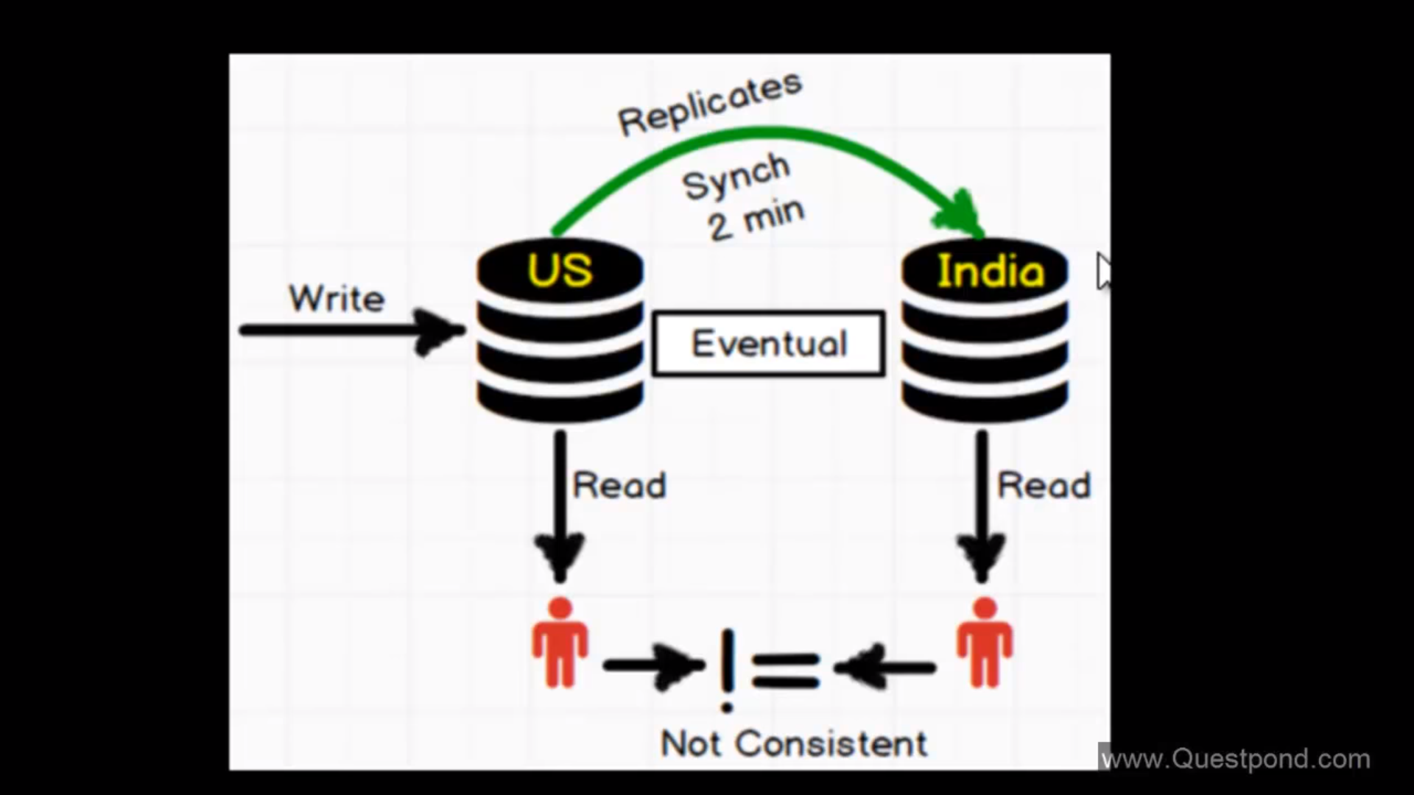

When the synchronisation has not finished , data is not consistent in two regions it is k.a Eventual Consistency, which means we do not do anything. We leave it to network , transaction, other factors to replicate the data. Now this is OK when we do not have mission critical data. But this will not work for ex in case of Stock Markets where we cannot afford to have inconsistent data at different regions.

For this, we can use following consistency, It does not allow uses at Read regions to read data which is not committed.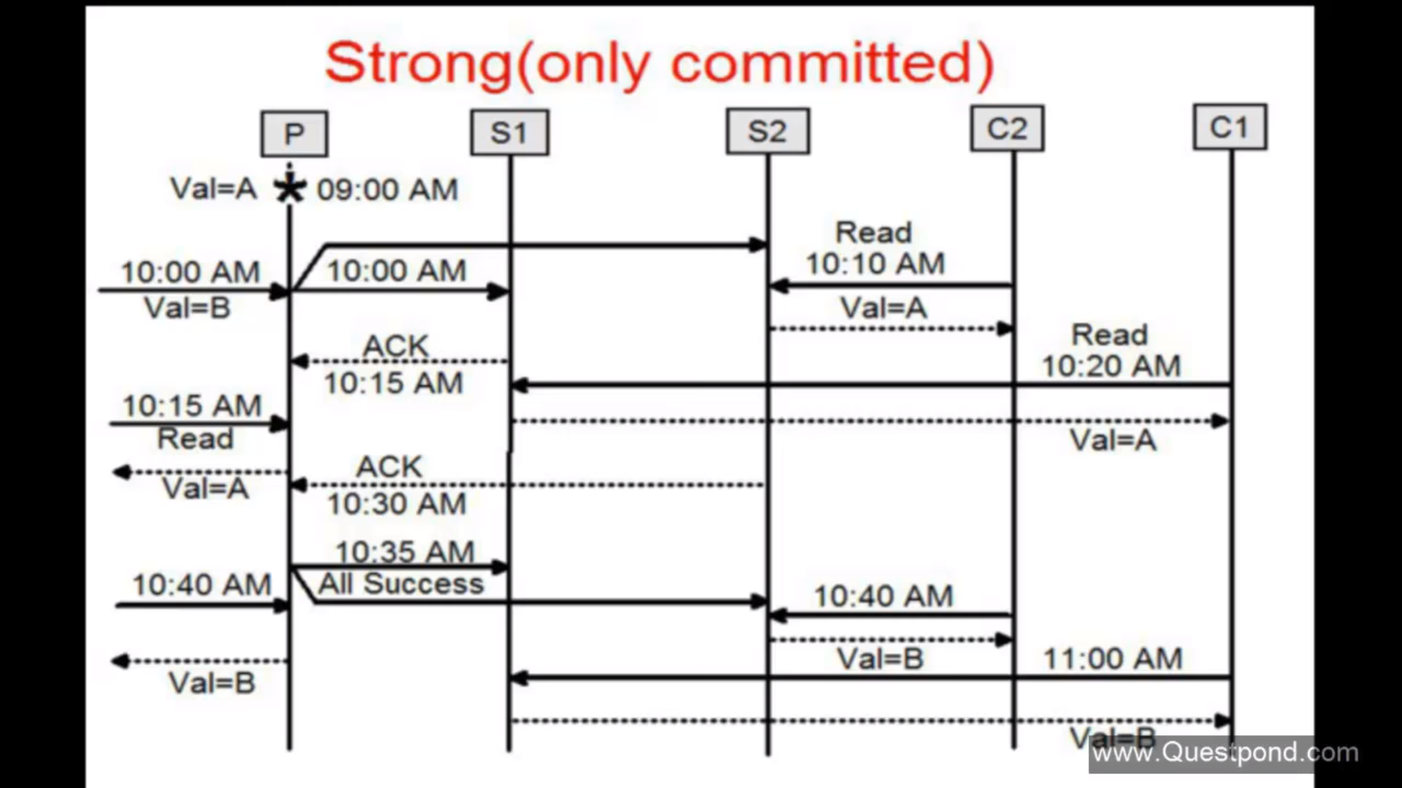

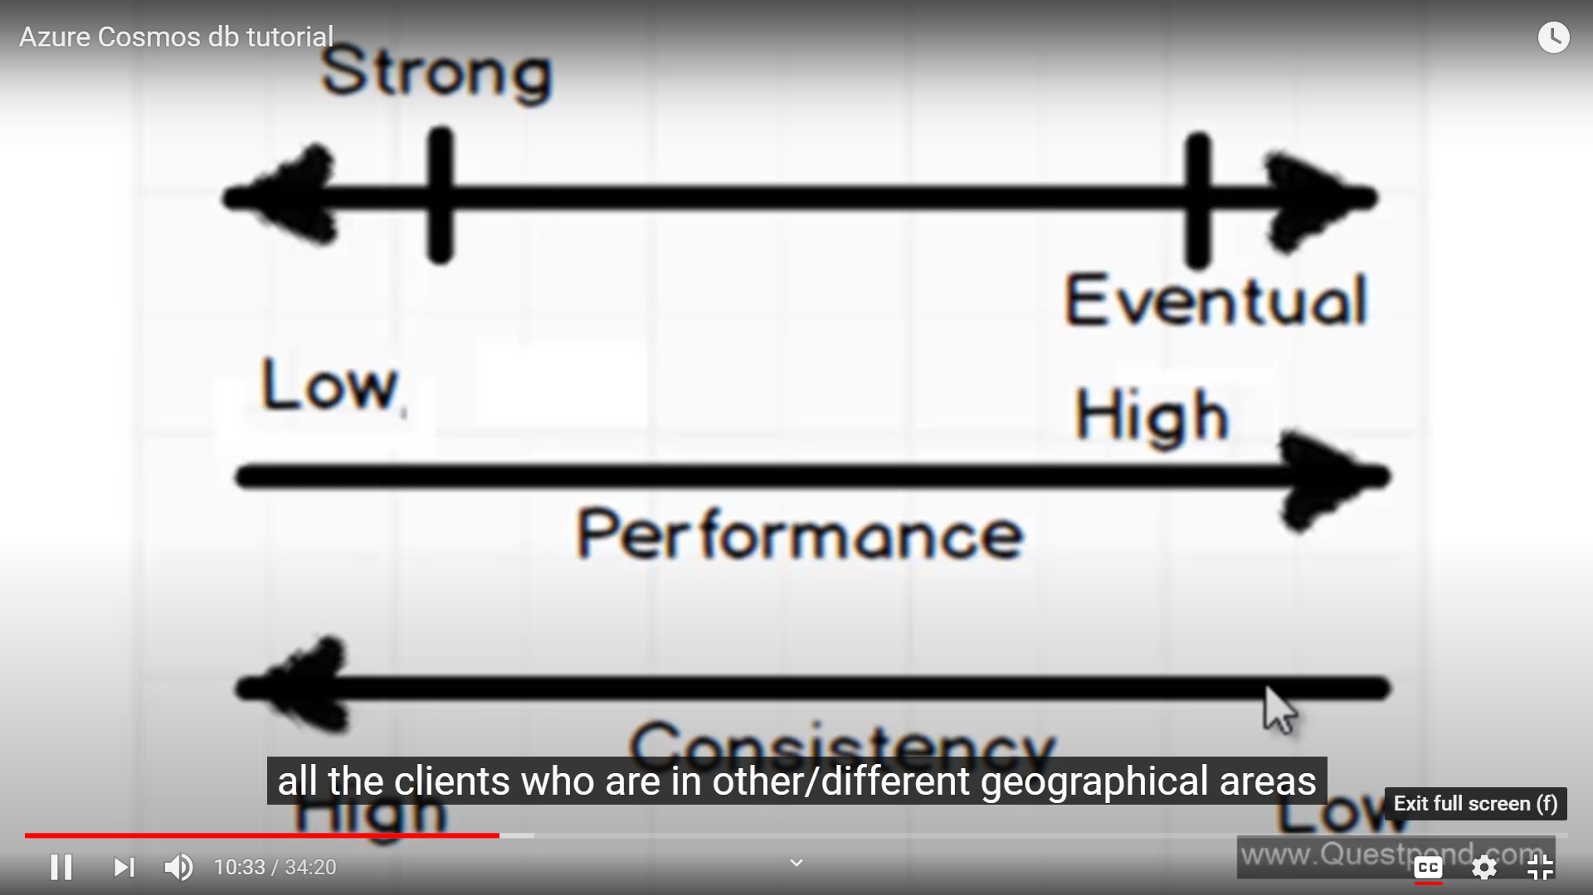

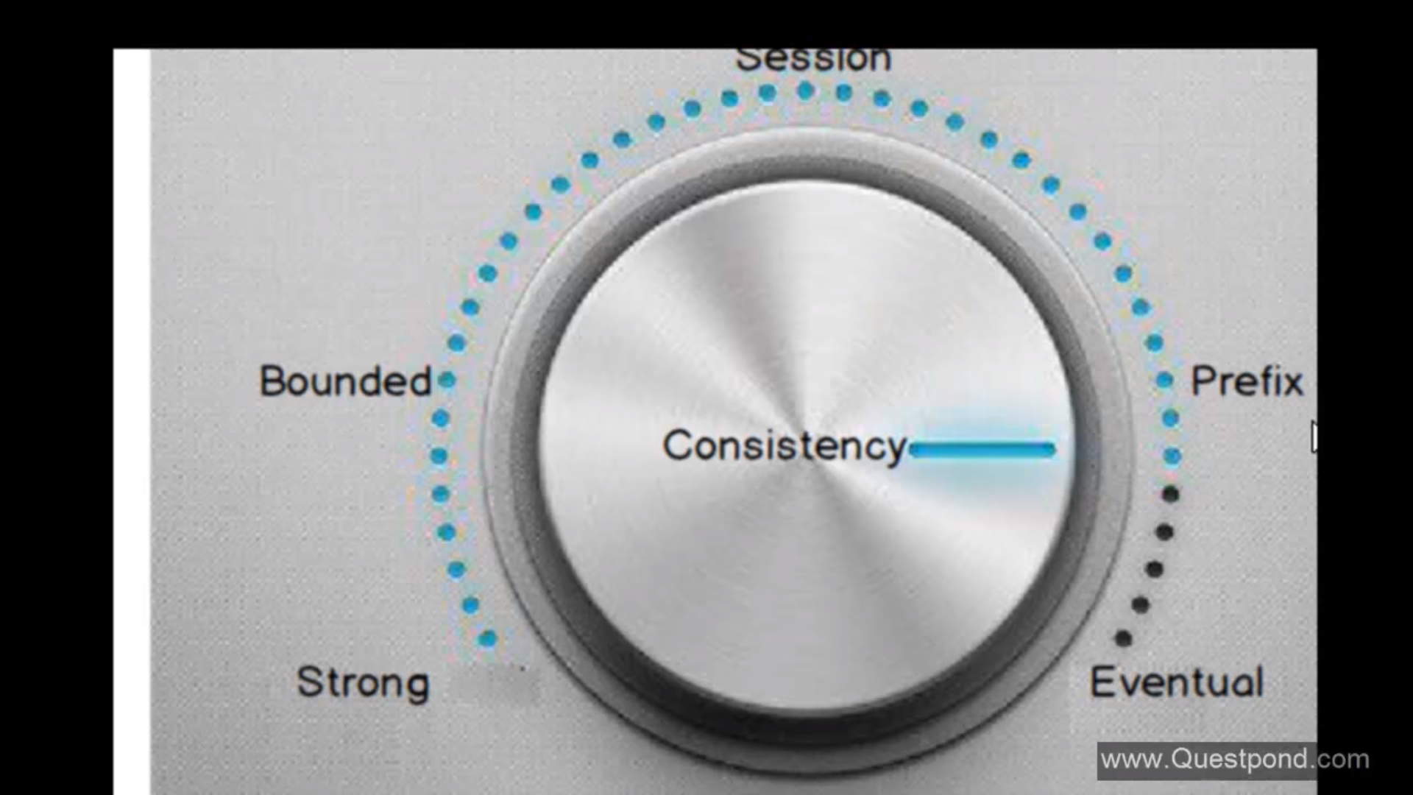

Bounded : Here we will see data which is some hrs old. If we set staleness to 2 hrs. So, All the clients will be lagging by the Write database by 2 hrs. If we set Bounded staleness period to 0, it becomes strong coinsistency.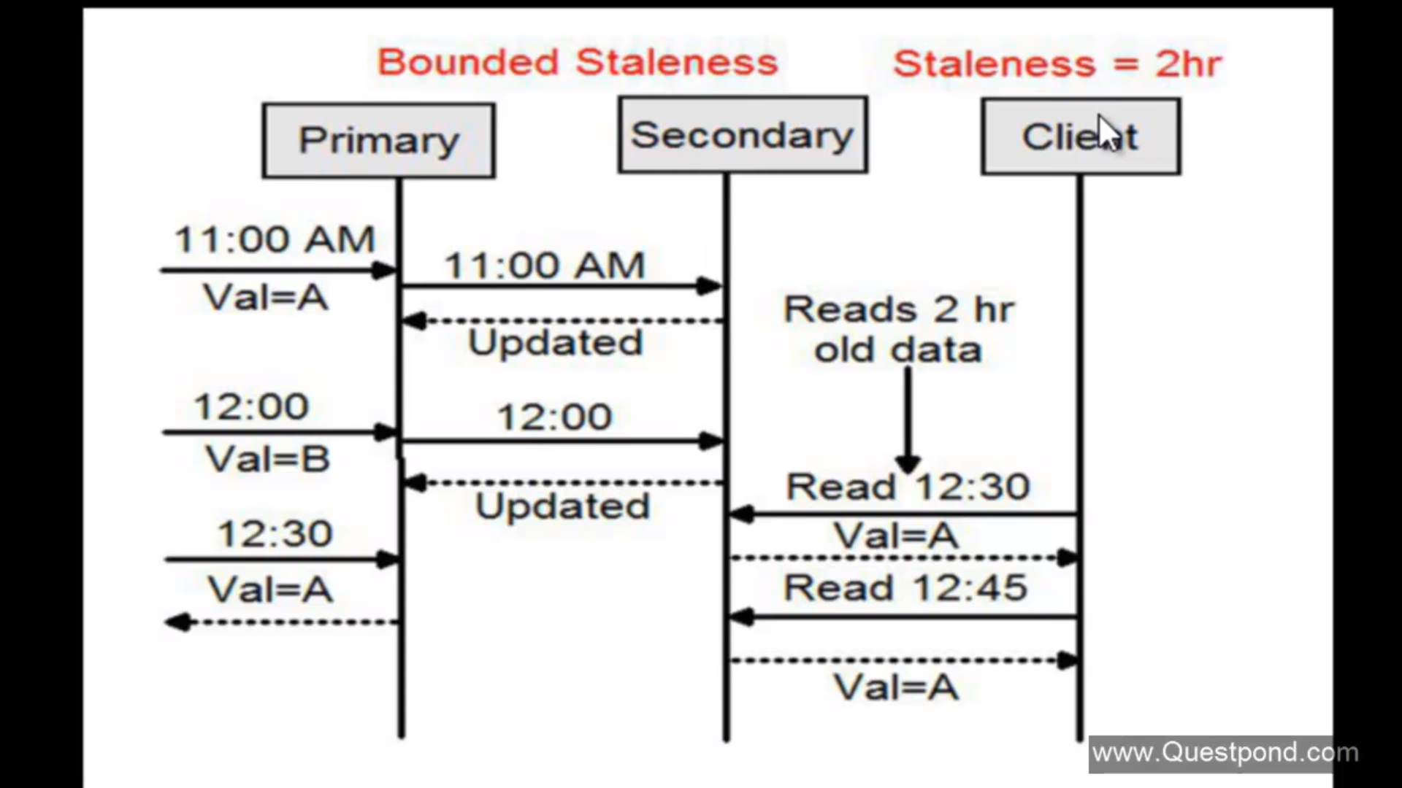

Session : Readers who will read from India will use Eventual Consistency. But the uses who will read from Write Database will see consistent or latest data. Its for clients who are updating the database that they shud see the updated data.

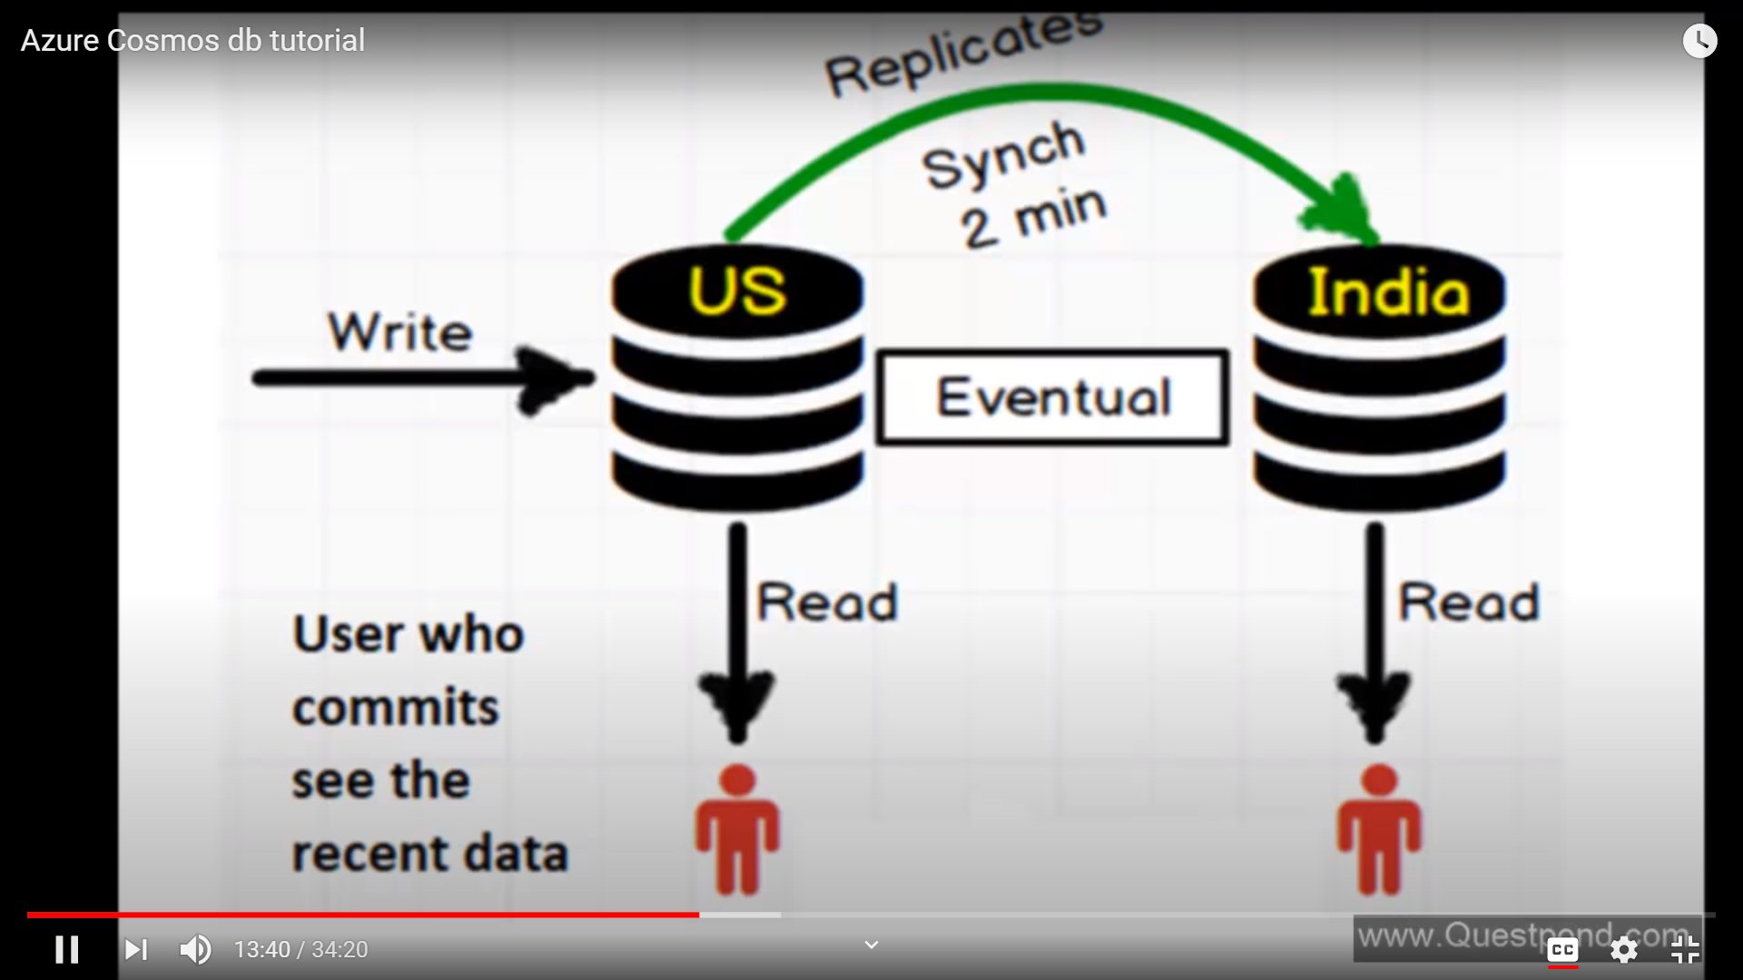

Consistent Prefix : Data is seen with same order as it is committed to the Write Databse. Data read by the client is always in order

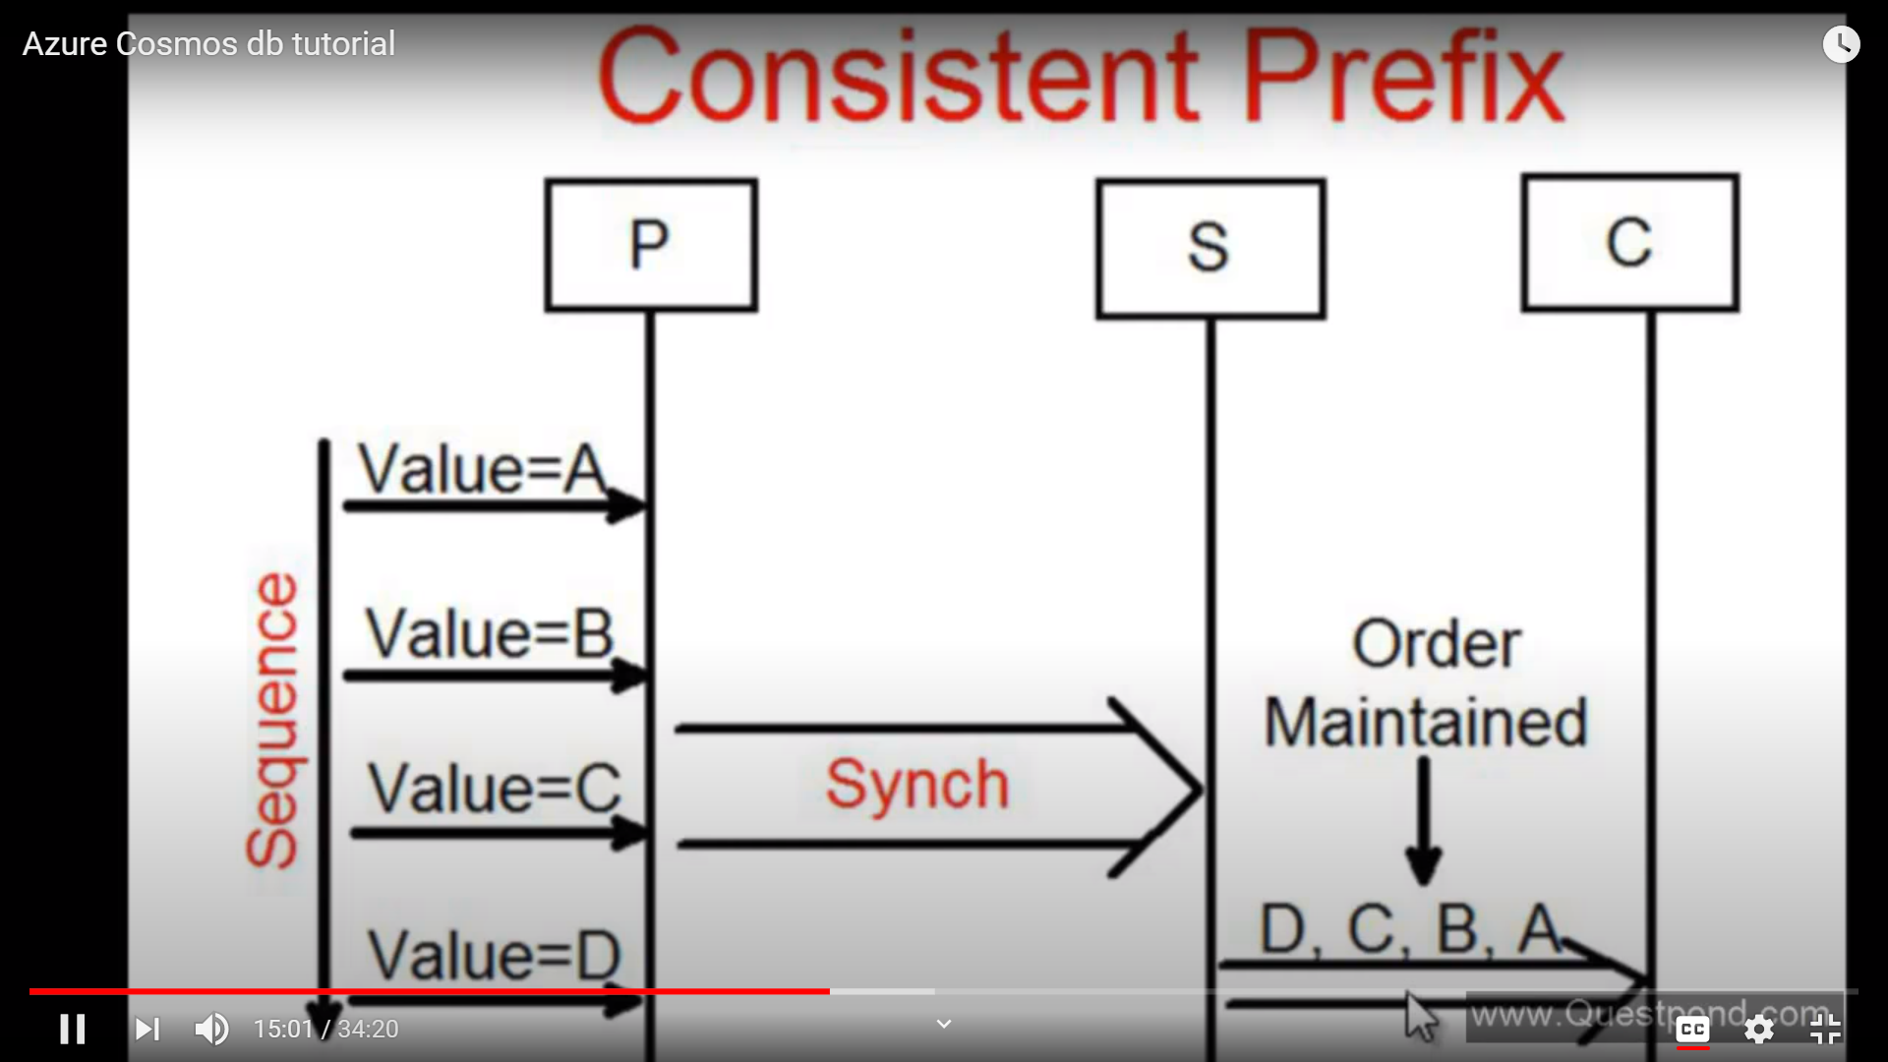

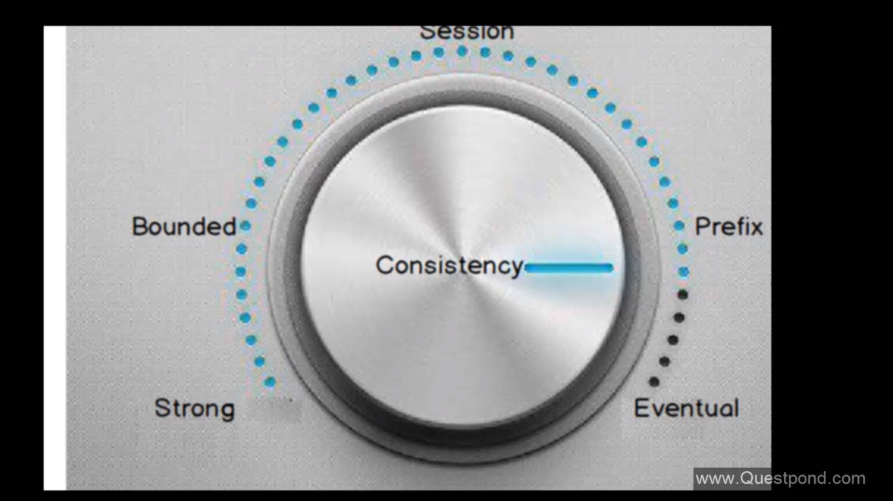

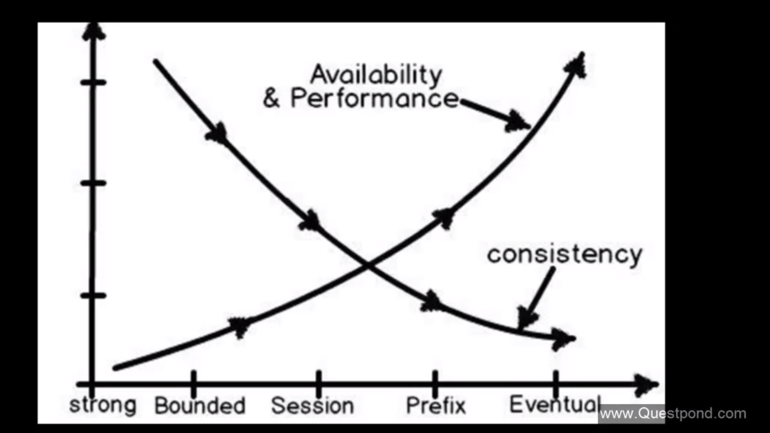

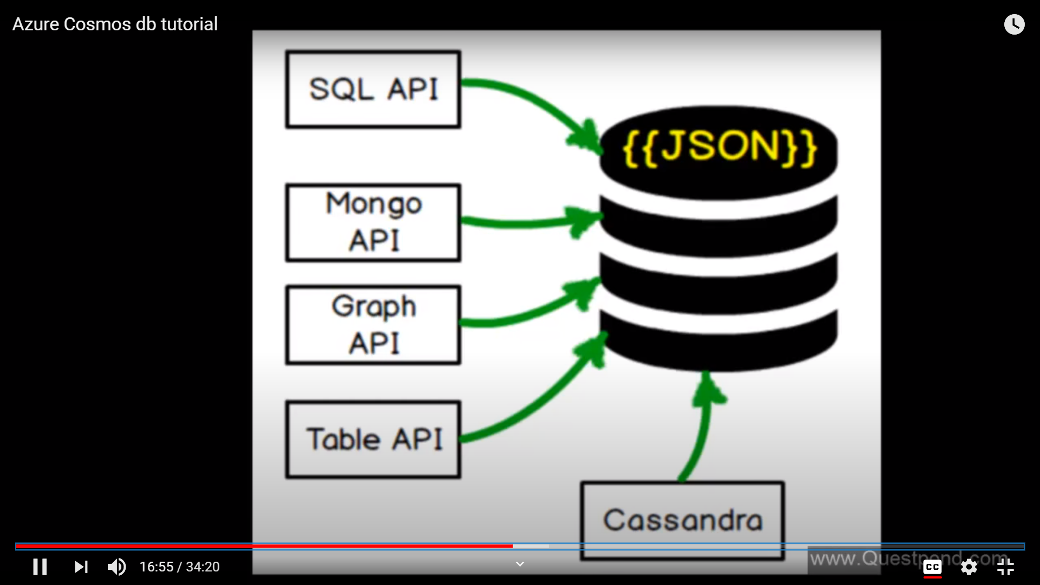

MutiApi support means that data is stored in json form but we can use any API in which you are comfortable in.

**Cosmos DB** exposes the **data** in JSON format. ... Based on the chosen API, the desired **data** model (graph, key-value, document or column) is projected on the underlying **data** store. Because of the way the **data** is **stored** and retrieved, you can use only one API against a container; multiple APIs usage is not possible.

What is NoSQl Database?

What is Cosmos DB? Collections, Documents, Scaling, Throughput, Partition Key,

Demo : Creation of Cosmos DB

What is Collection in Cosmos DB and creation of Collection in Cosmos DB

What is Document in Cosmos DB and creation of Document in Cosmos DB

Can I access Cosmos DB without subscription?

-------------------------------

What is Cosmos DB?

It is schema free

Unlimited scaling (Horizontal as well as Vertical)

Its Document DB (2015) (Its only supported json format)

No Relation (No joins)

Multimodel support (Supports json, tables, graphs)

<https://azure.microsoft.com/en-in/blog/a-technical-overview-of-azure-cosmos-db/#:~:text=The%20core%20type%20system%20of,%2Dsequence%20(ARS)%20based.&text=The%20design%20also%20enables%20natively,and%20Gremlin%20graph%20query%20API>.

<https://www.red-gate.com/simple-talk/cloud/cloud-data/overview-of-azure-cosmos-db/>

<https://docs.microsoft.com/en-us/azure/cosmos-db/create-graph-gremlin-console>

<https://www.spanishpoint.ie/news-blog/azure-cosmos-db-a-global-database-service-for-any-scale/#:~:text=Turnkey%20Global%20Distribution,that%20is%20closest%20to%20them>.

**Turnkey Global Distribution**

Cosmos DB allows you to build highly responsive and highly available applications on a **global** scale. The service transparently replicates your data wherever your users are and allows you to add or remove Azure regions so users can interact with a replica of the data that is closest to them

-------------------------------

What is Collection in Cosmos DB

Is it equal to table in SQL?

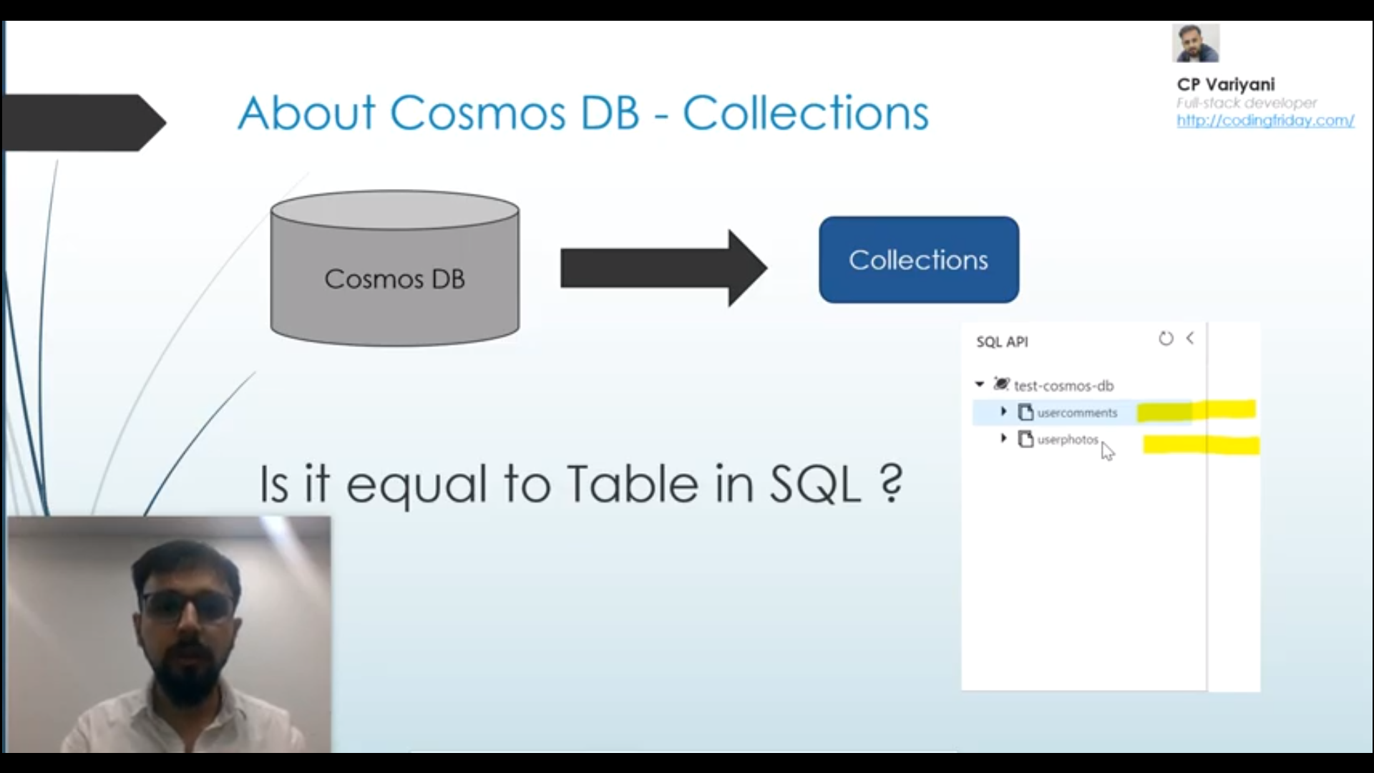

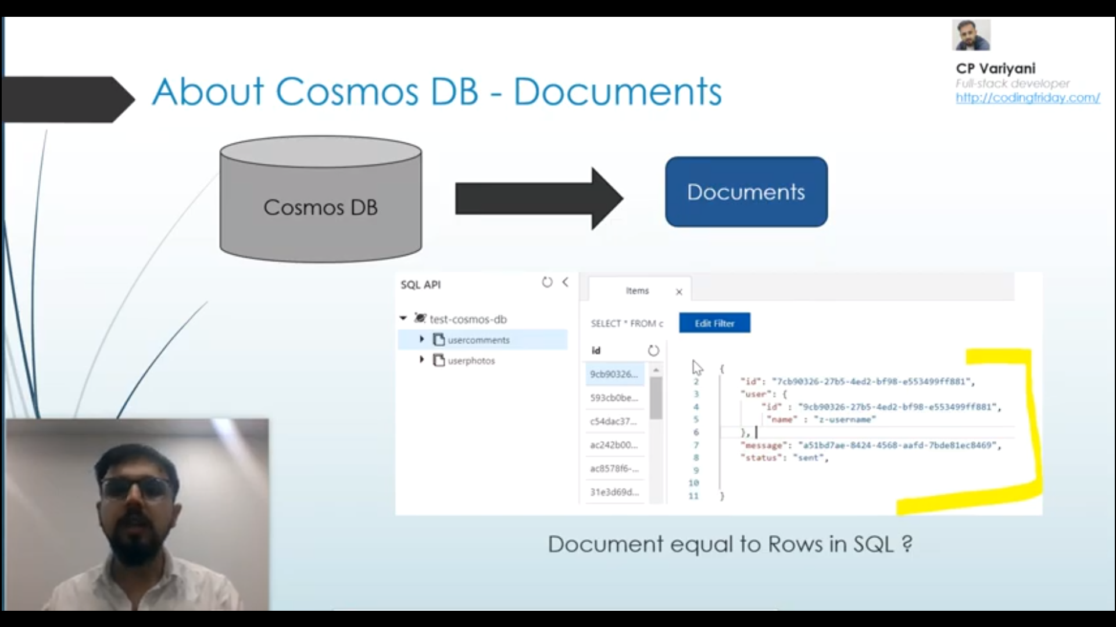

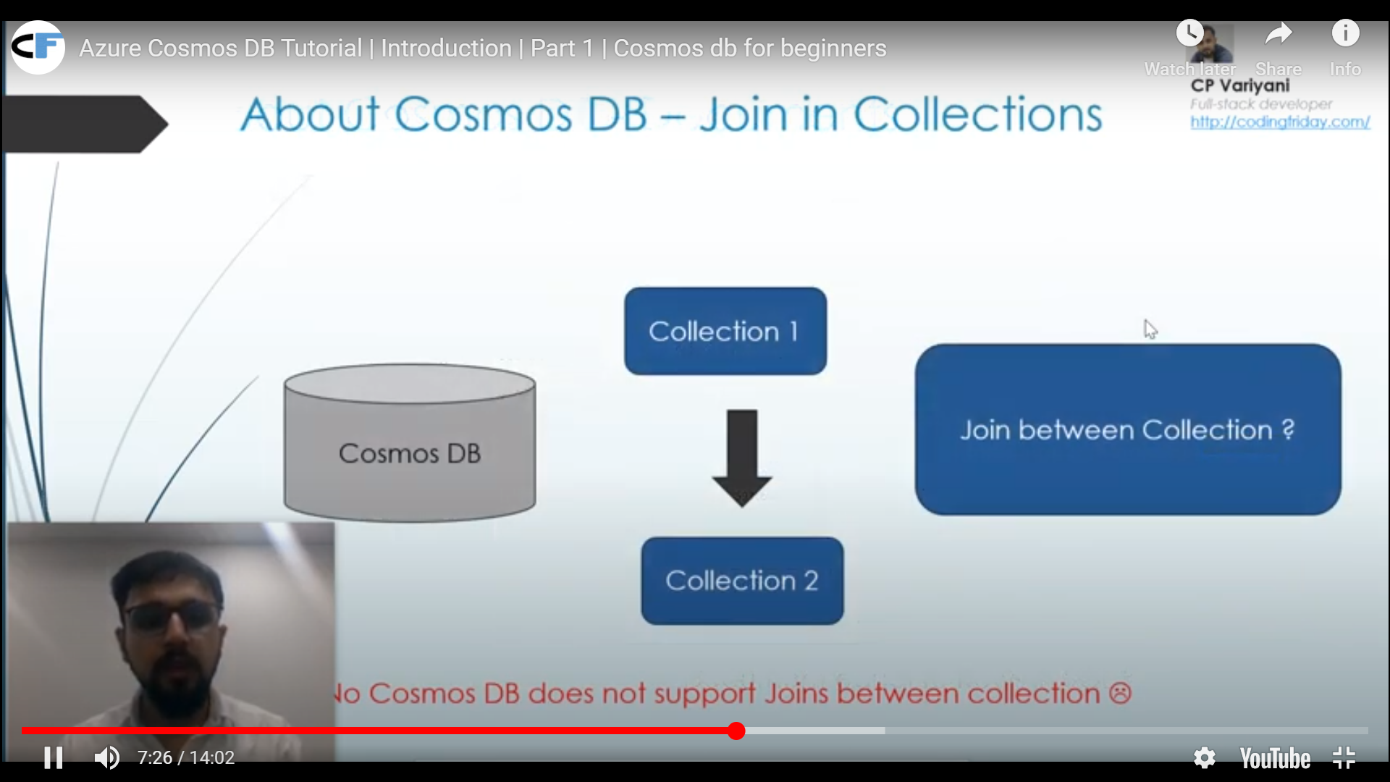

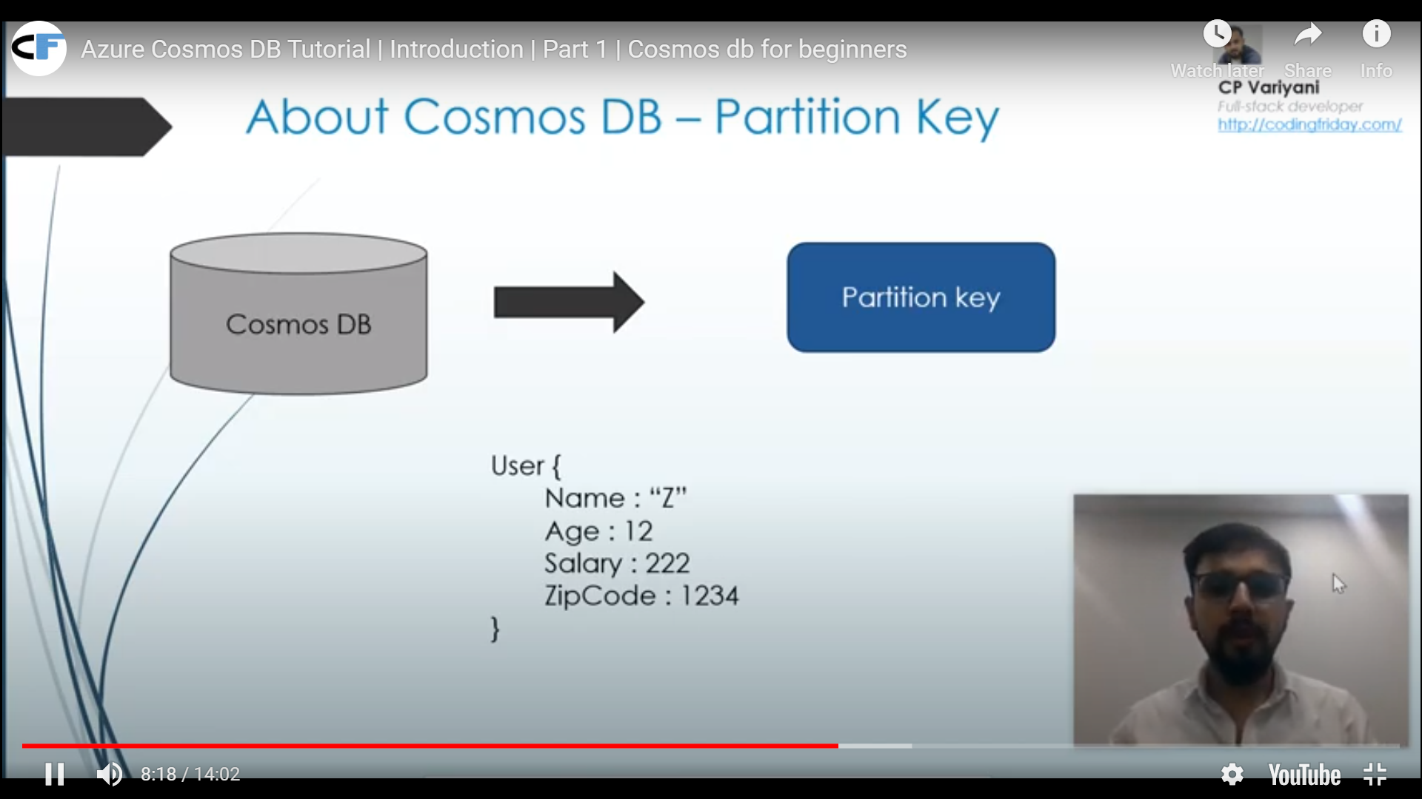

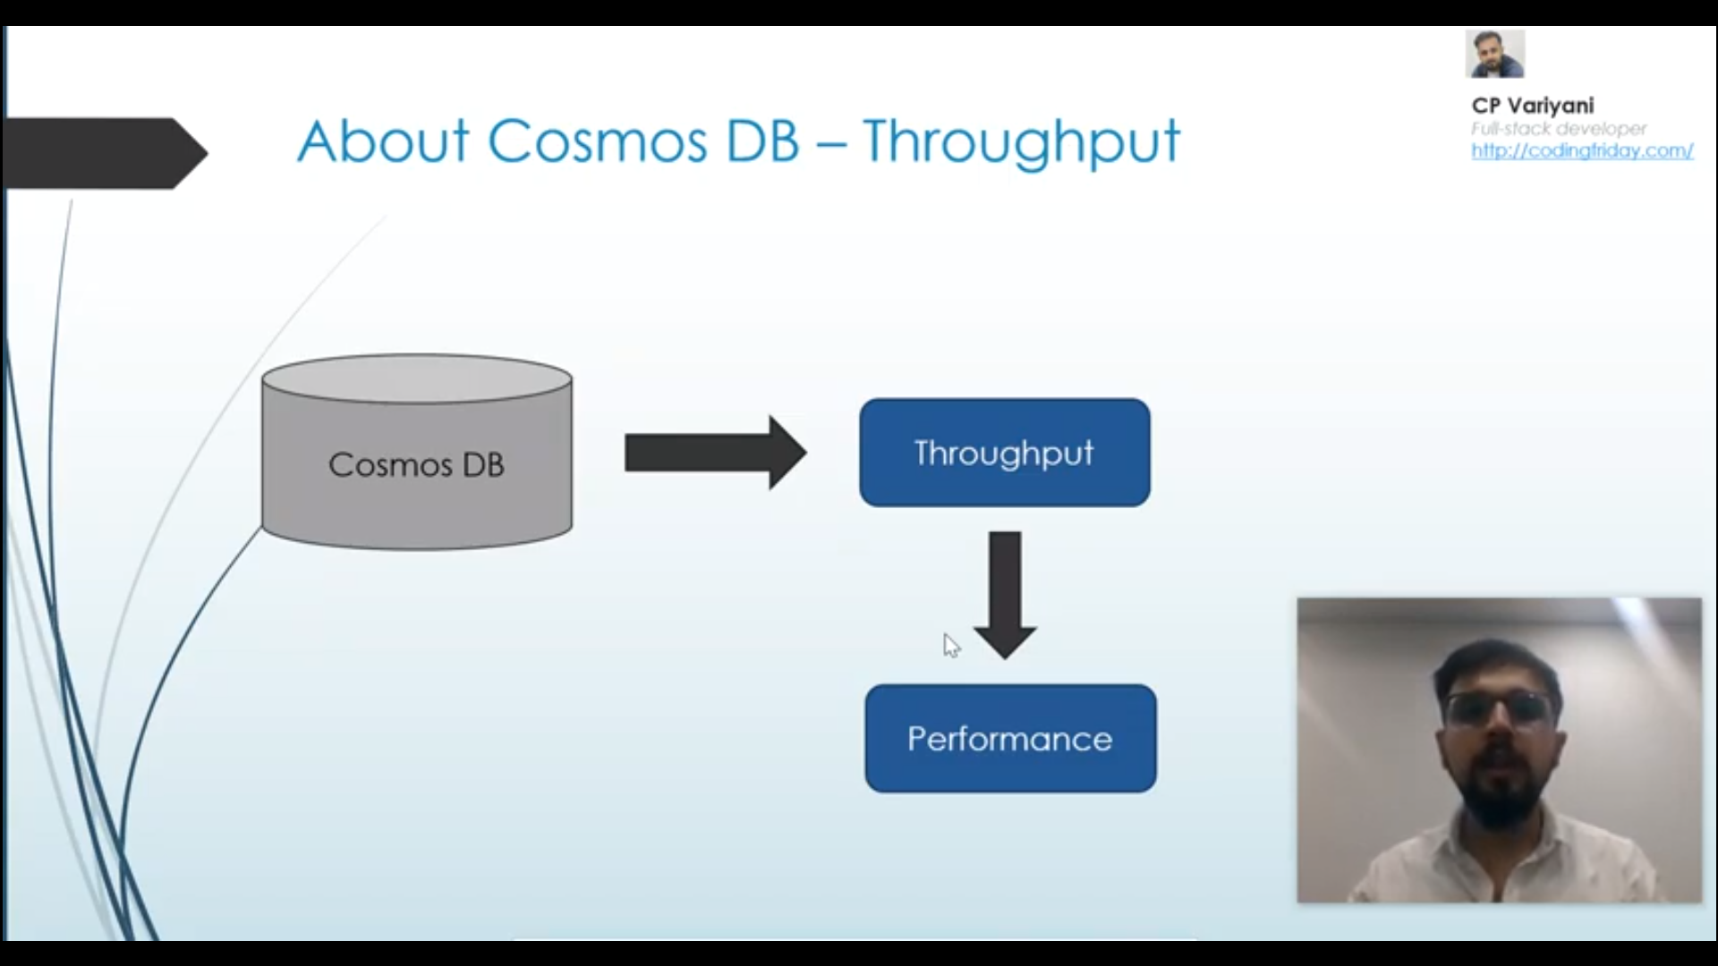

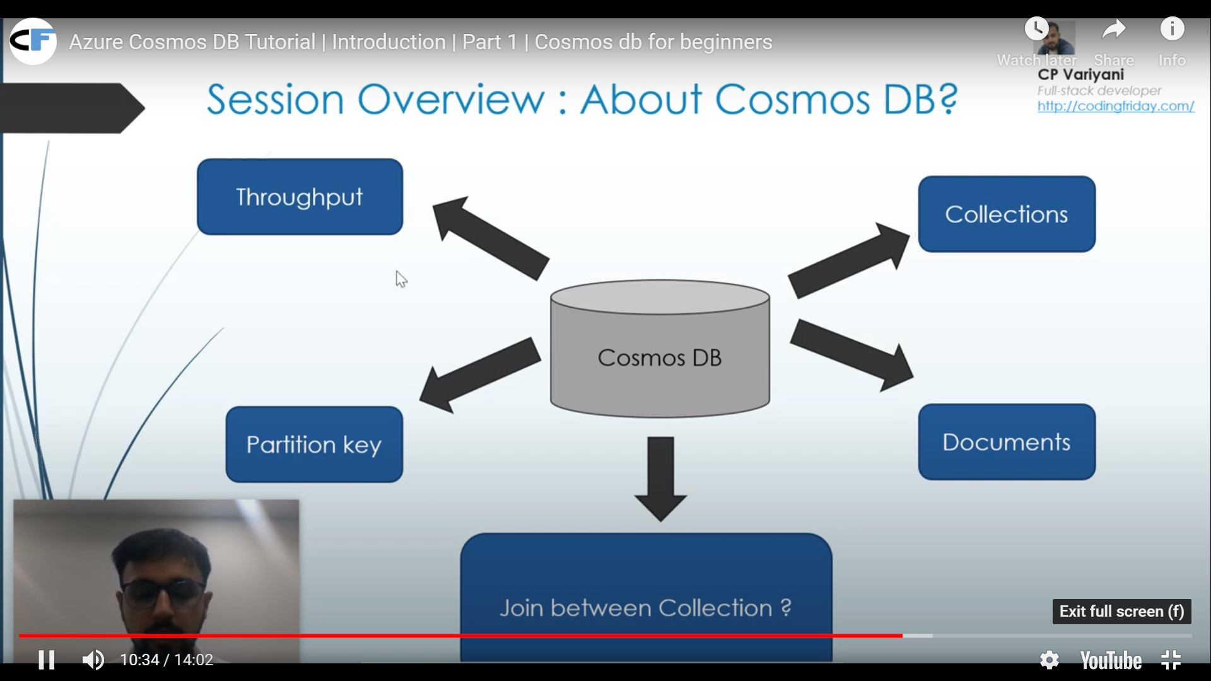

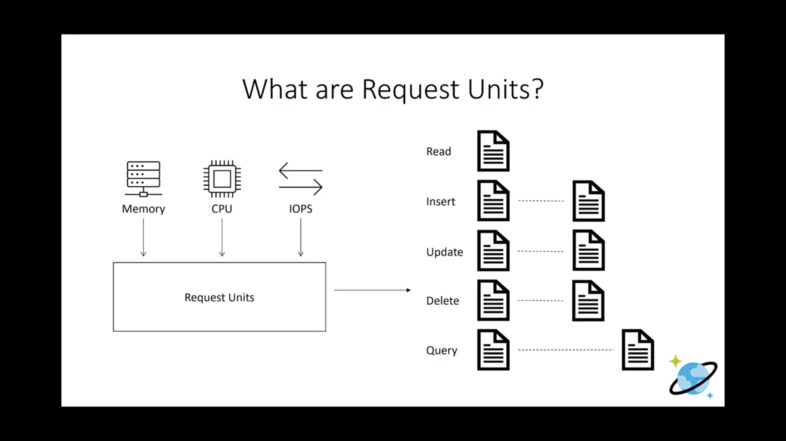

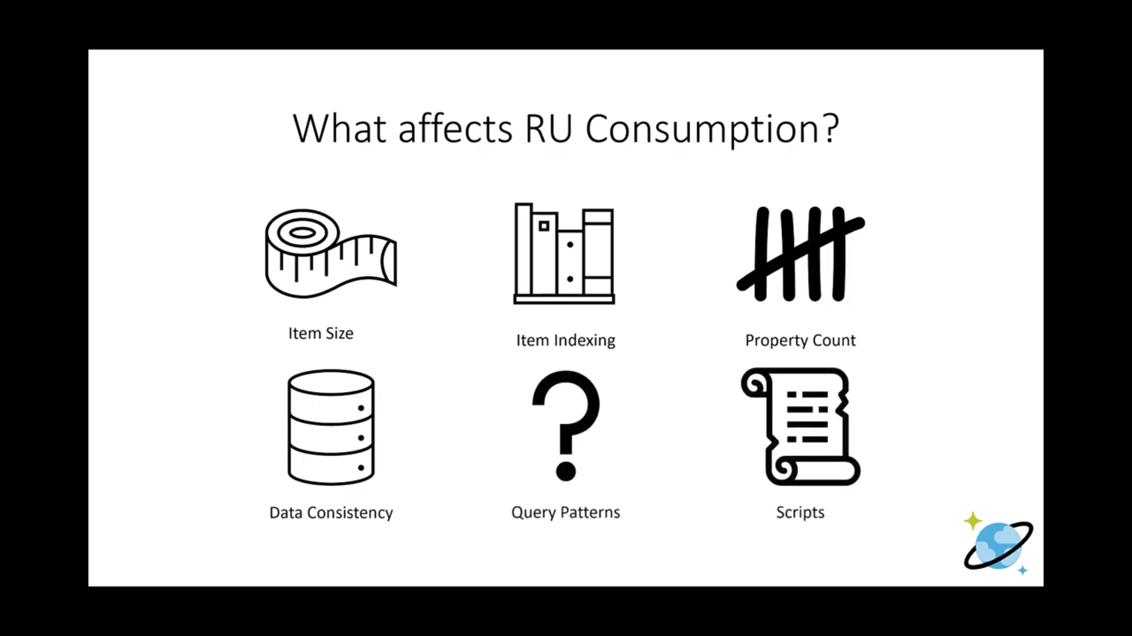

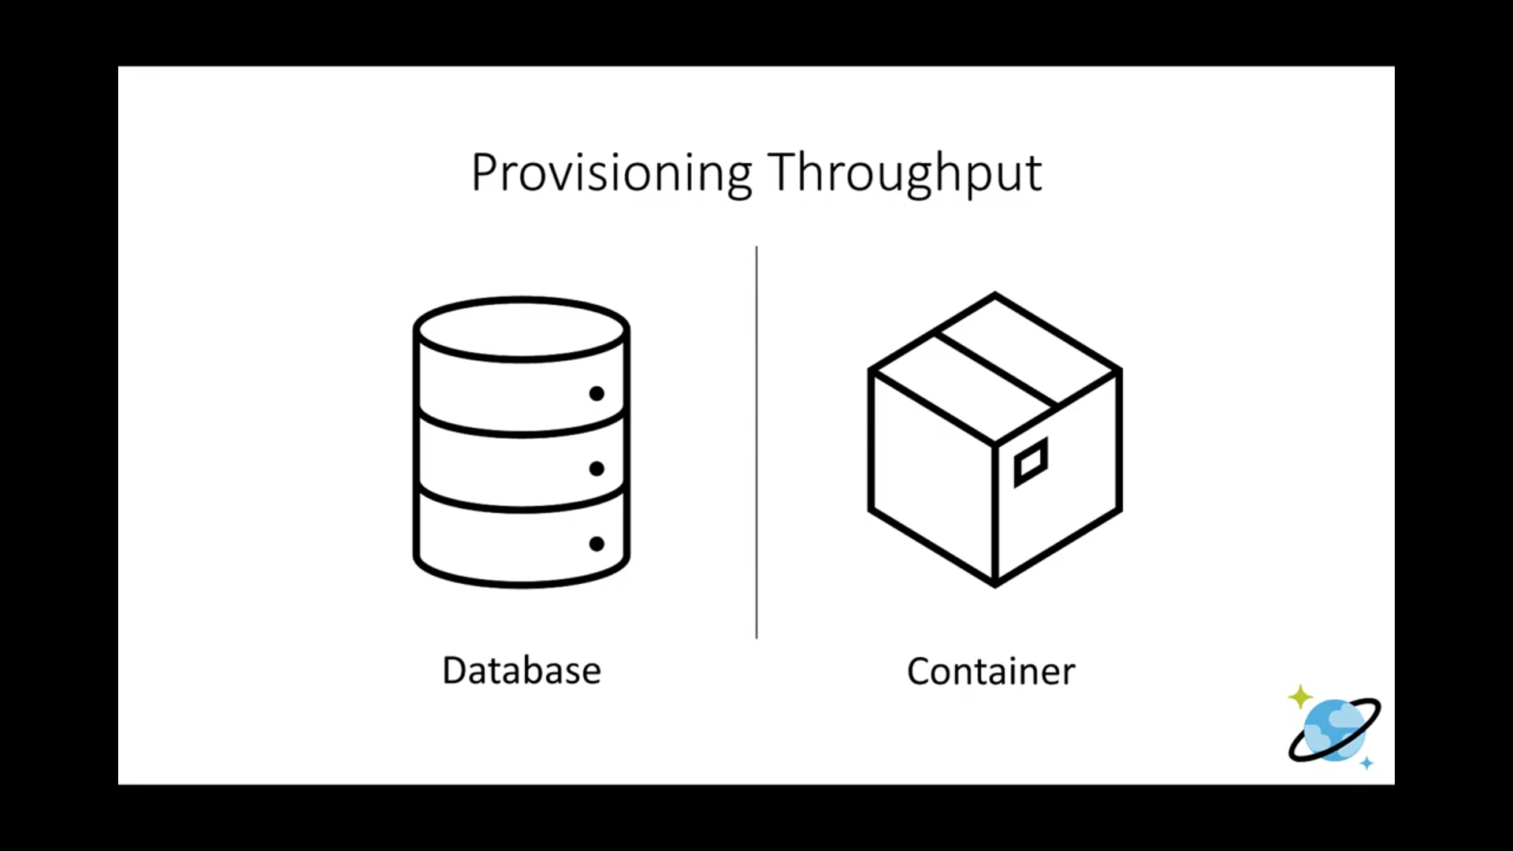

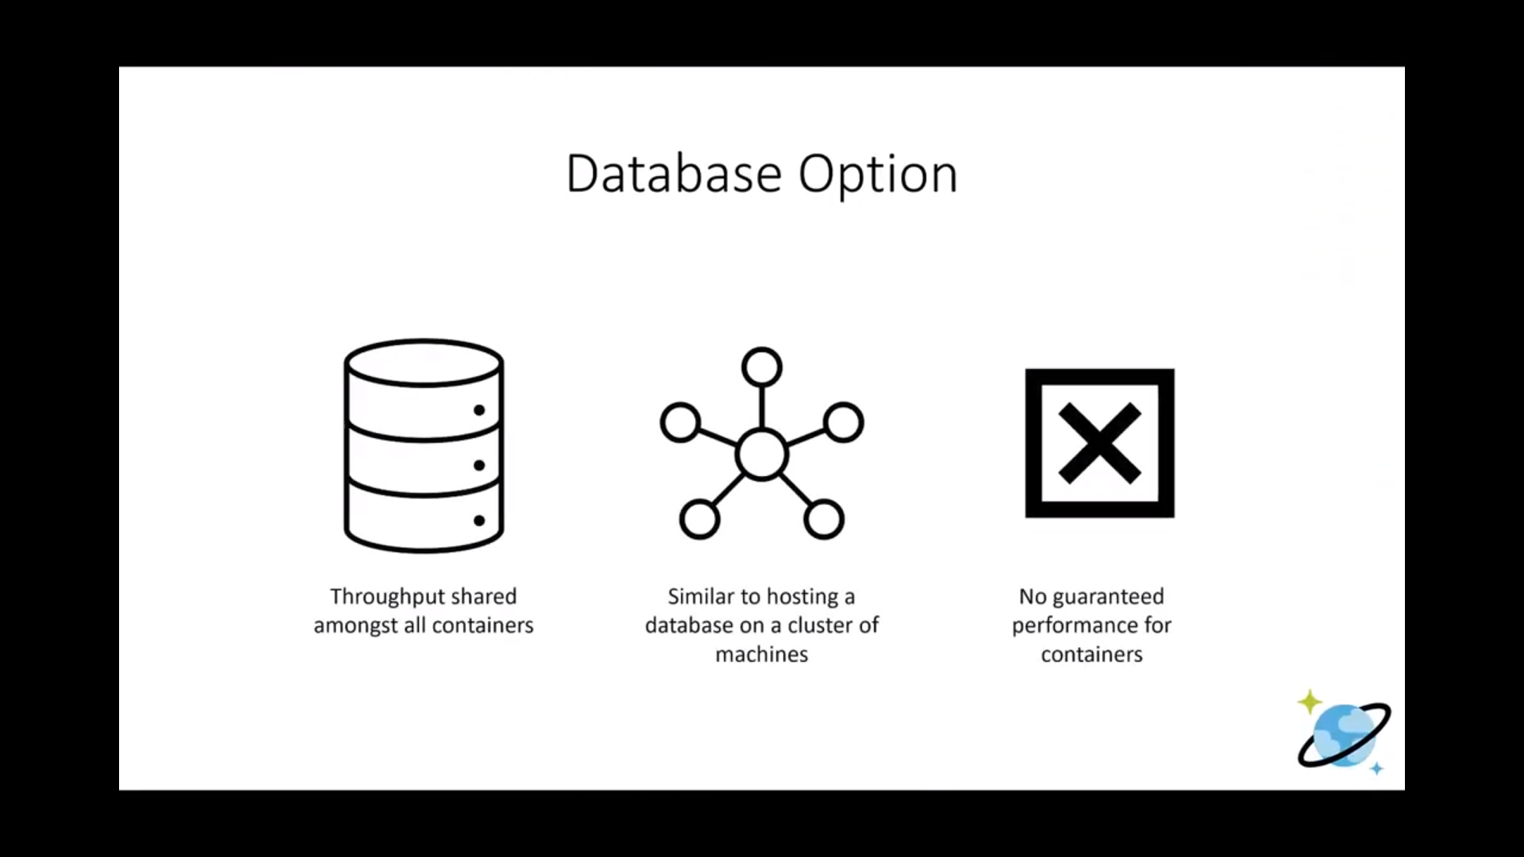

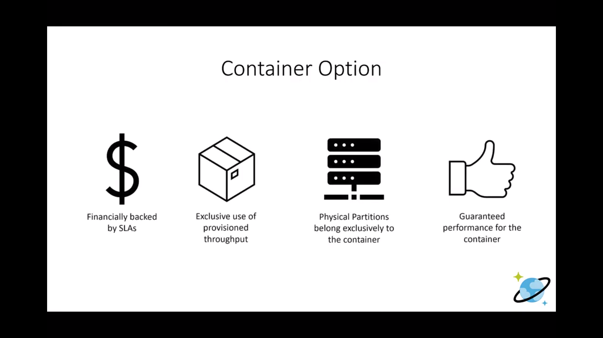

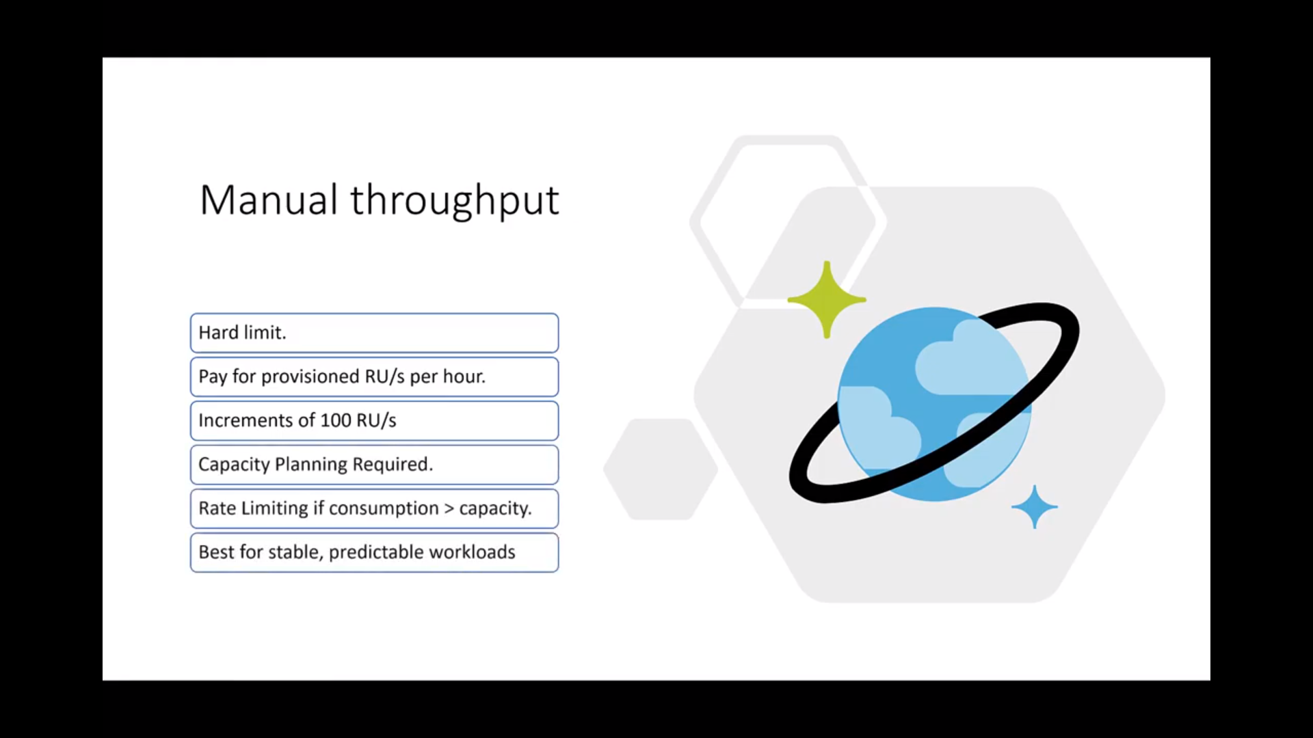

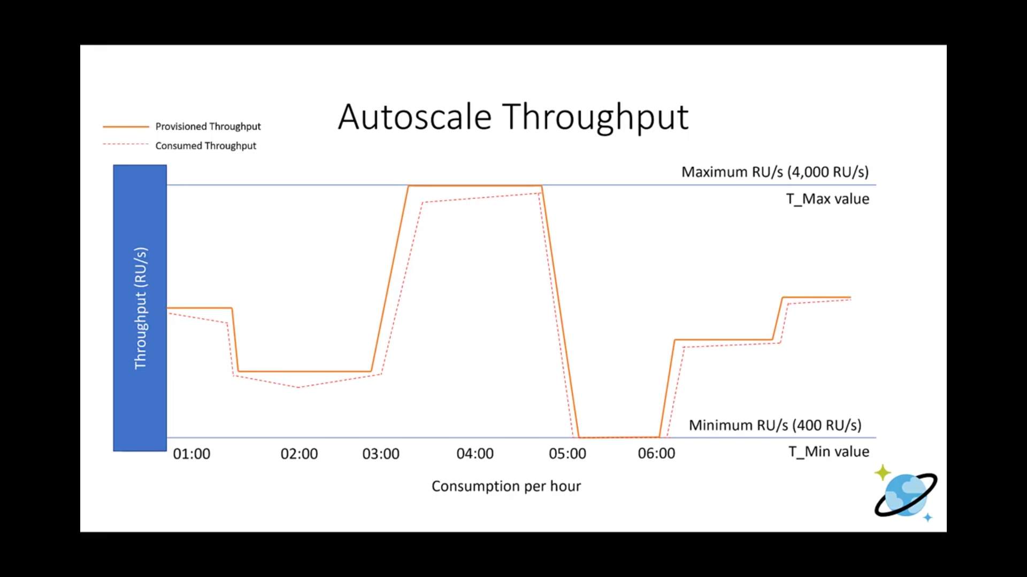

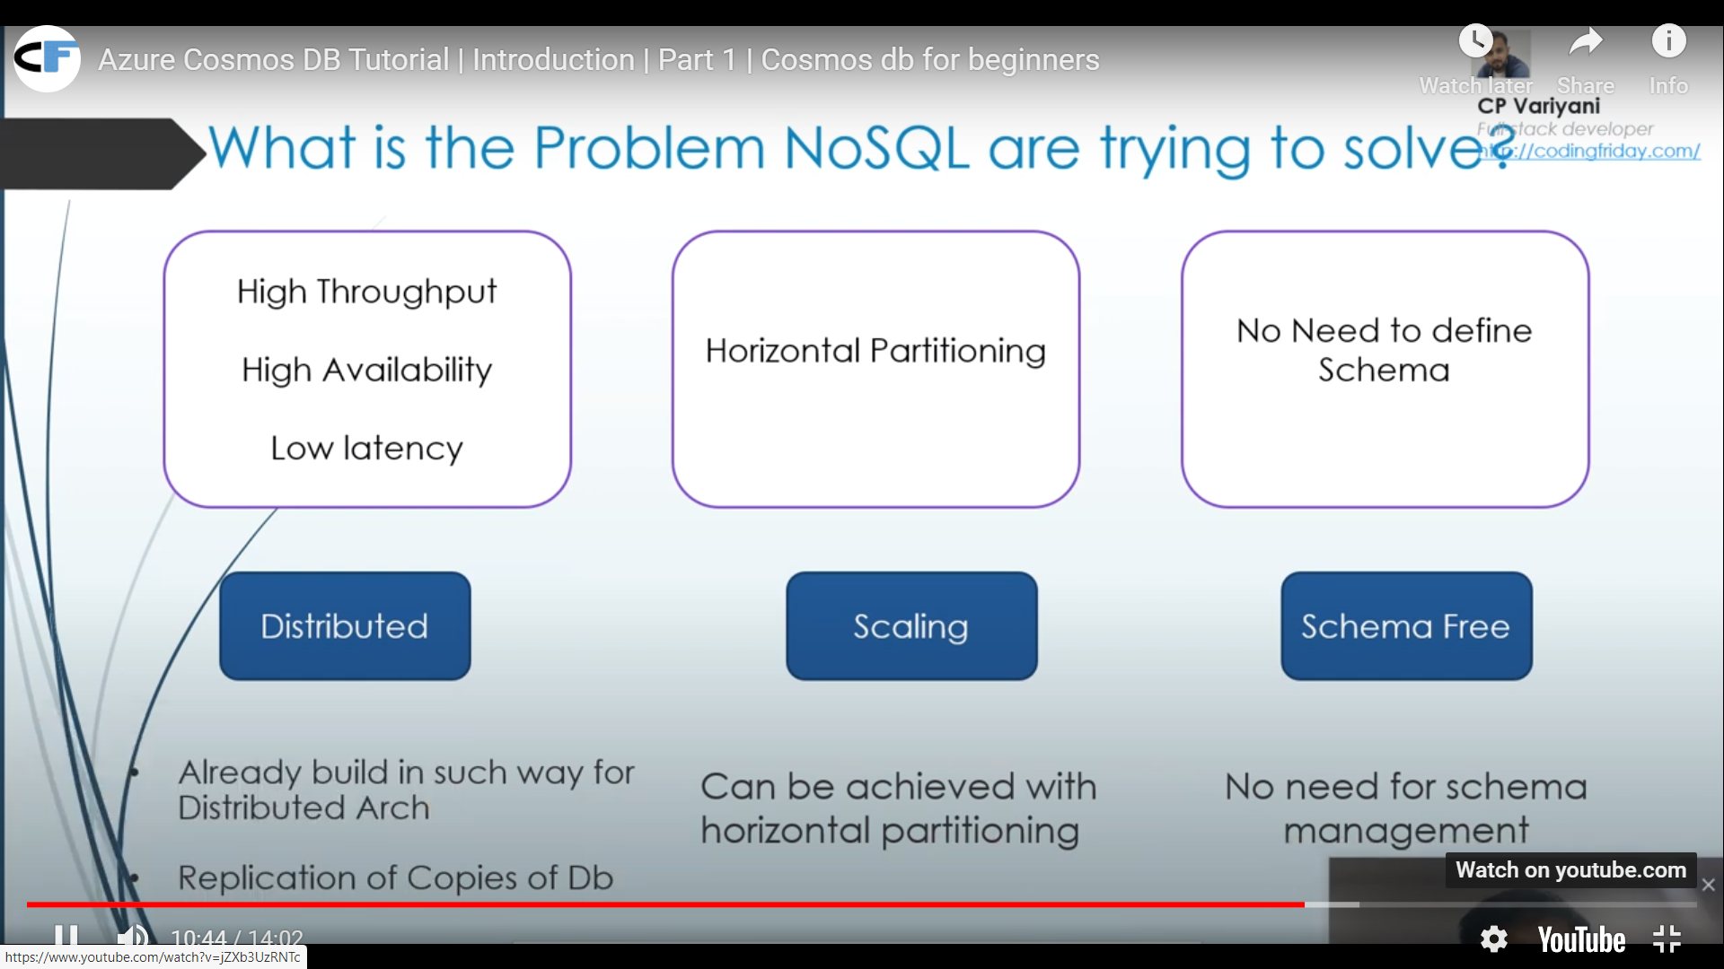

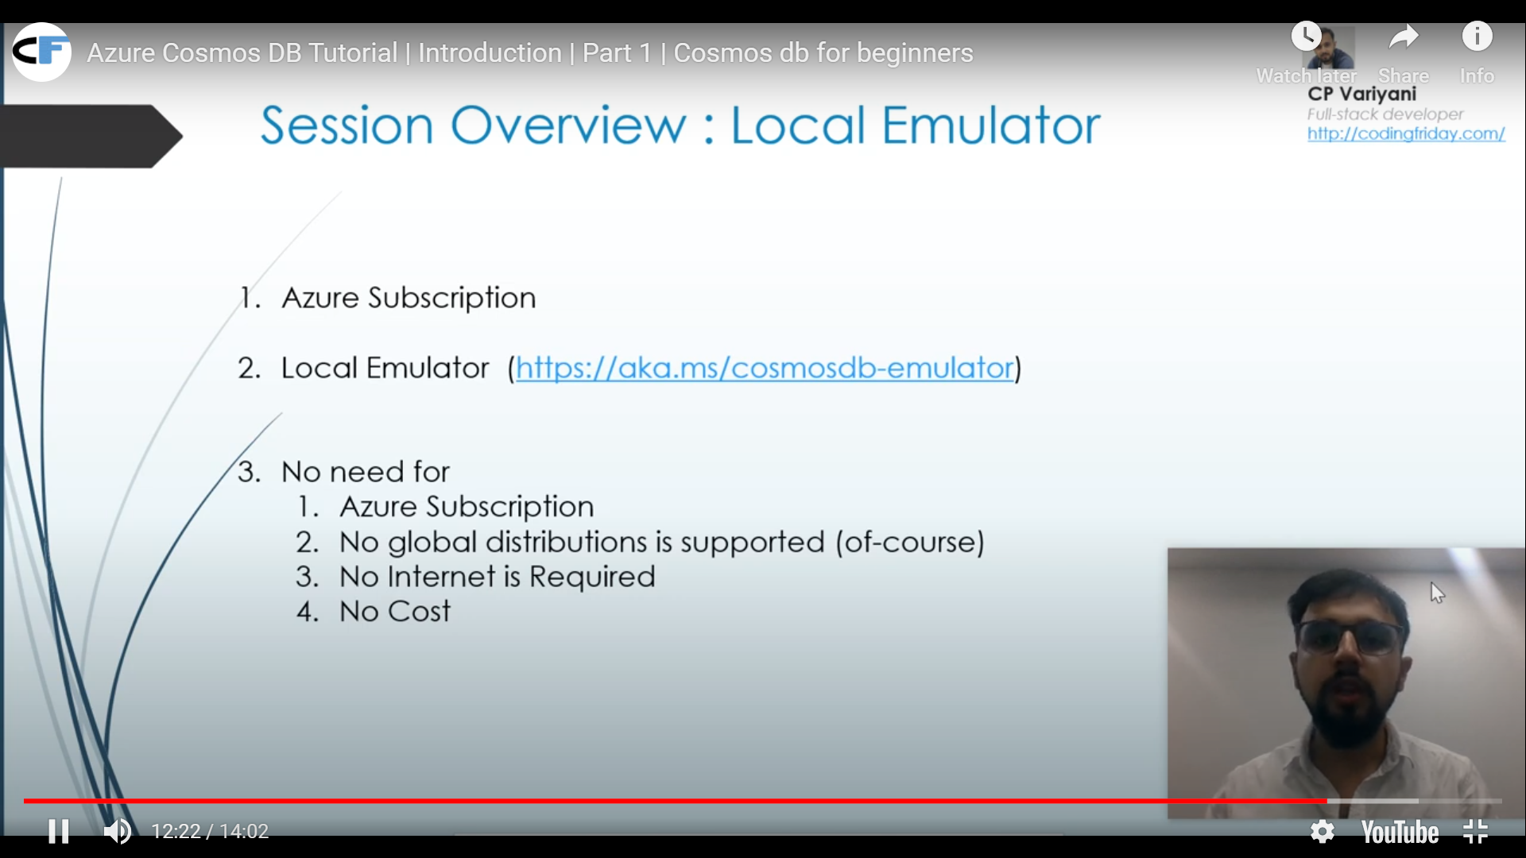

Steps to Create

While using Cosmos DB, we pay for storage consumed by the data and the oprations that we perform on that data.

Any opreartion tat you perfom cusumes some of the database resourcses expressed as Request Unit.

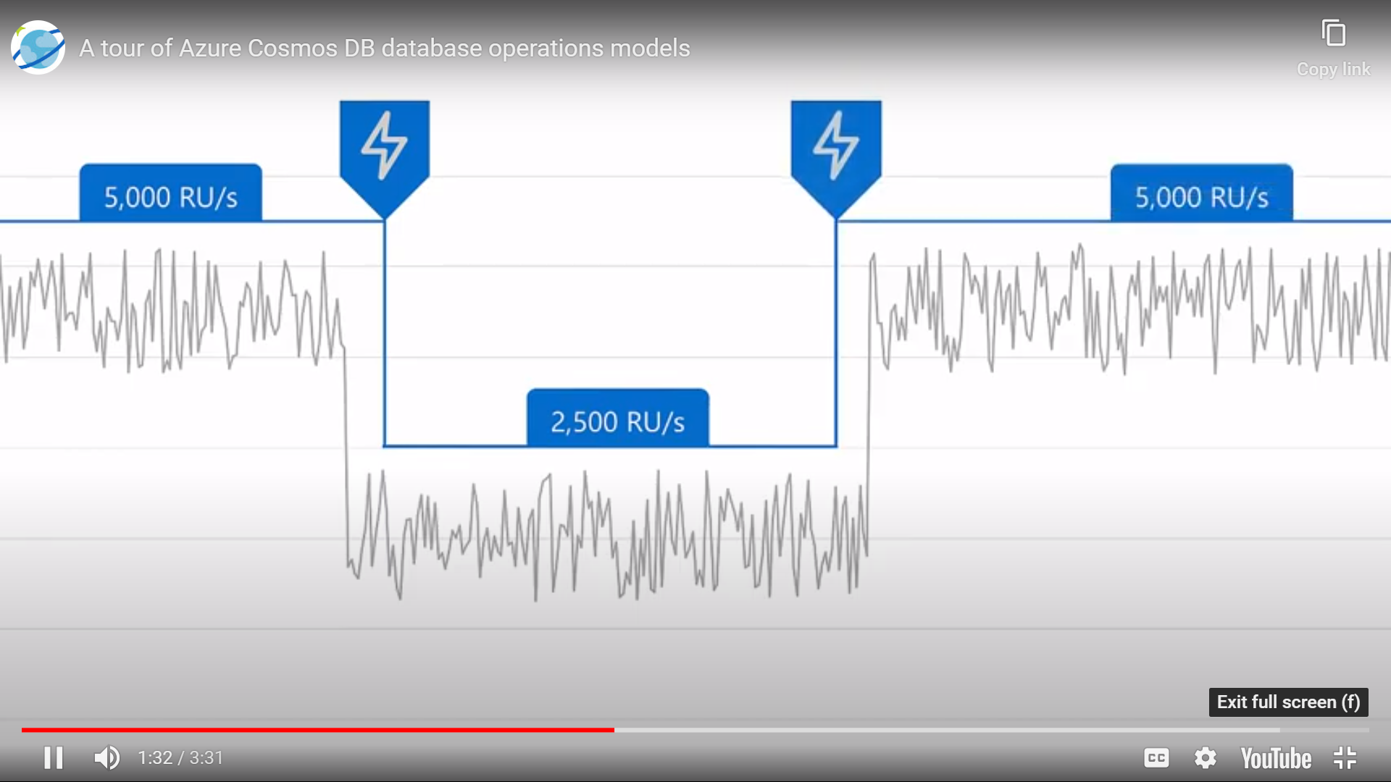 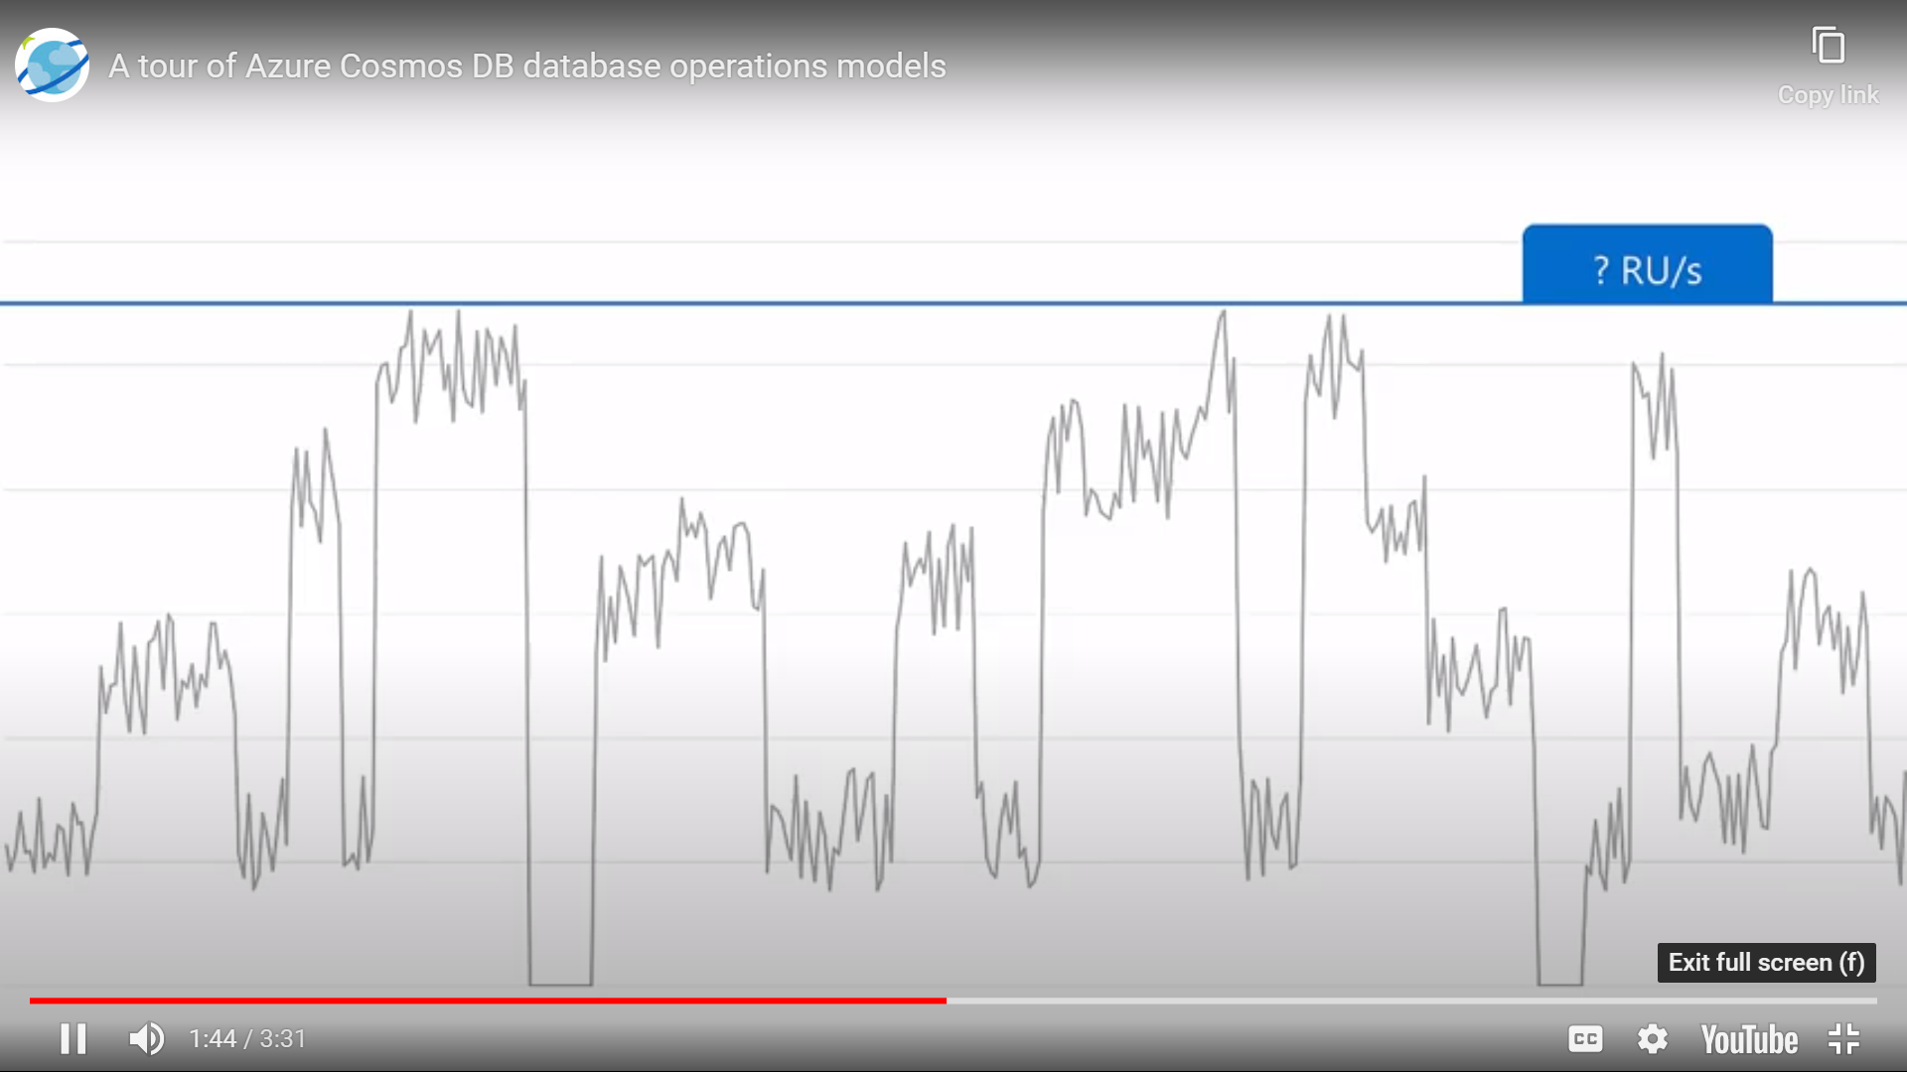

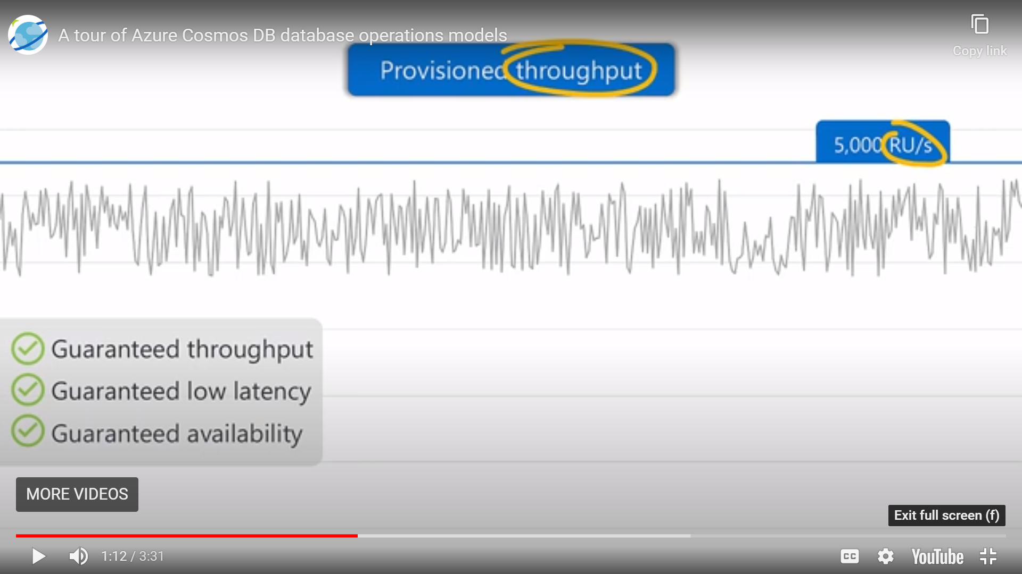 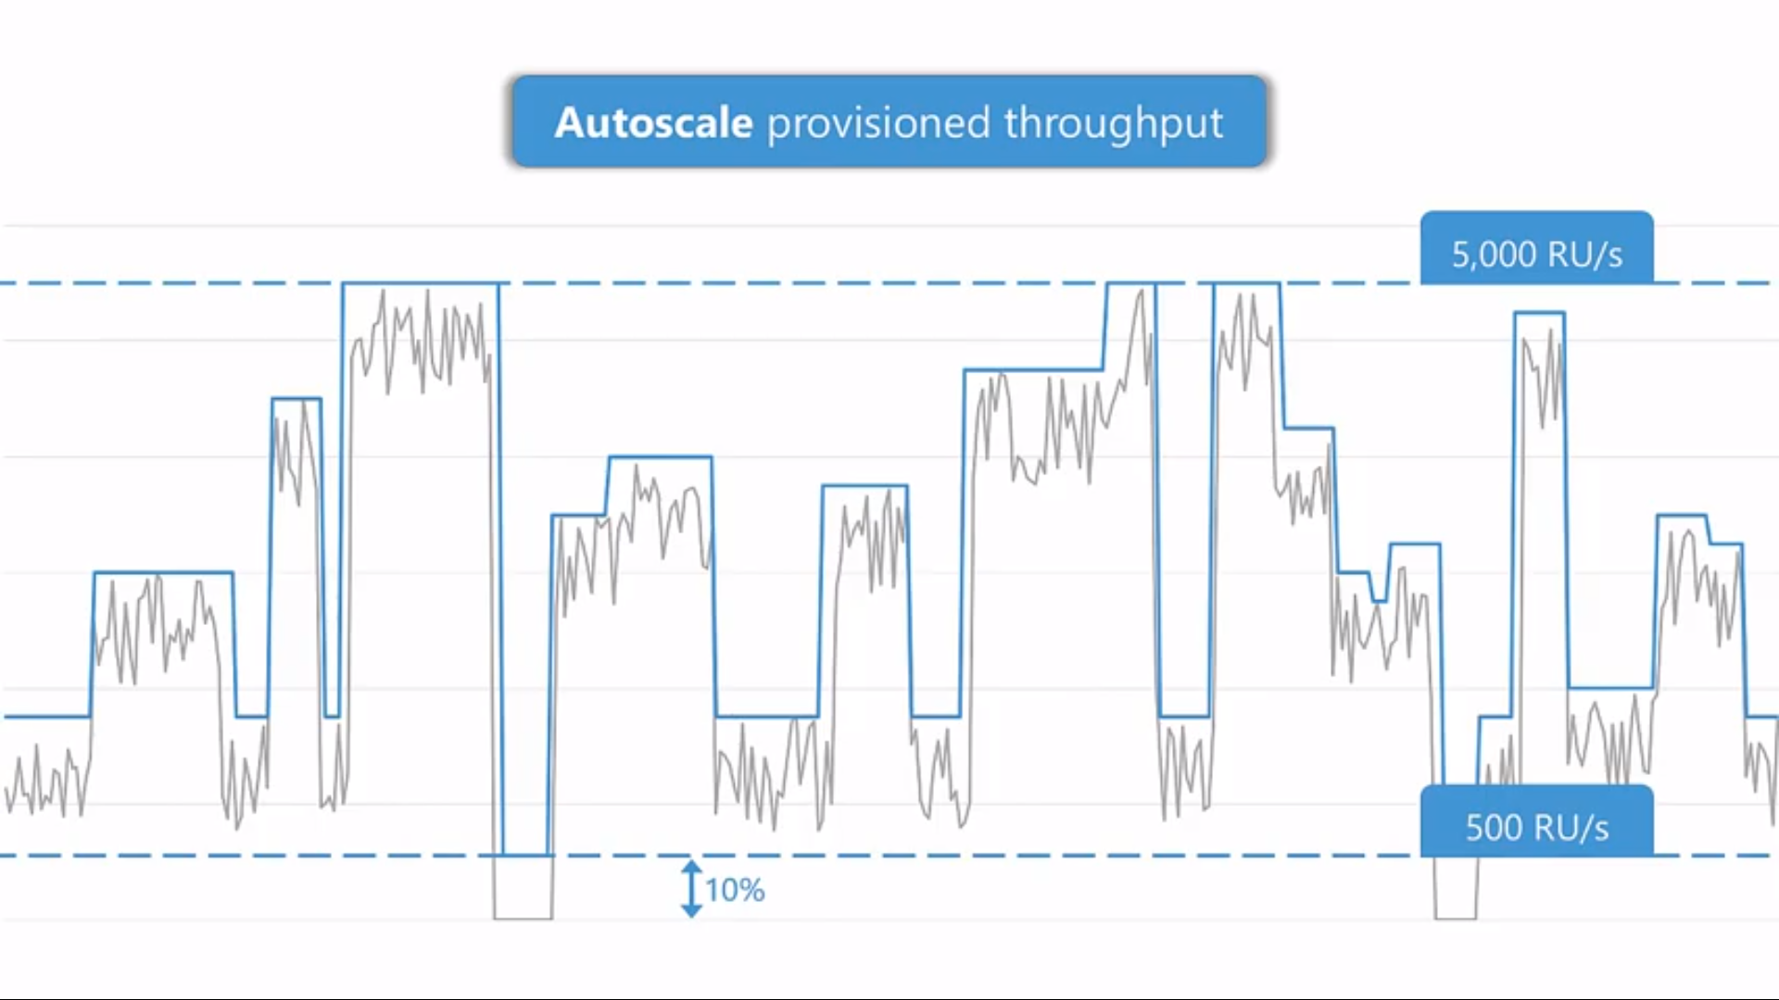

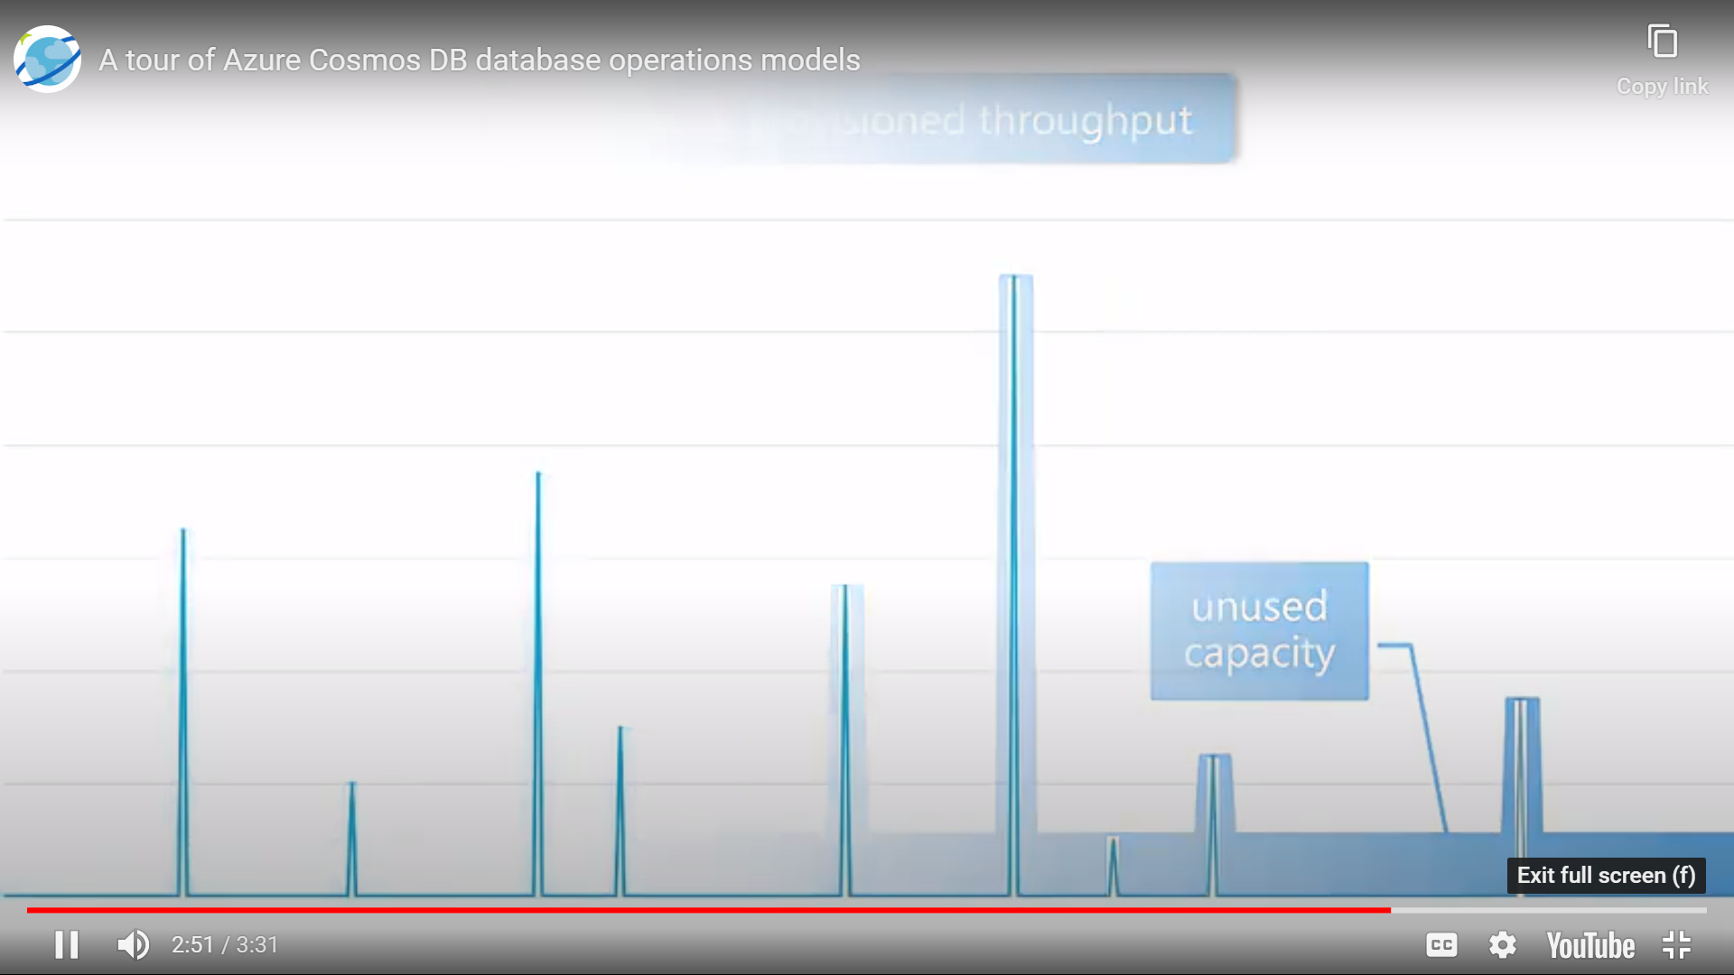 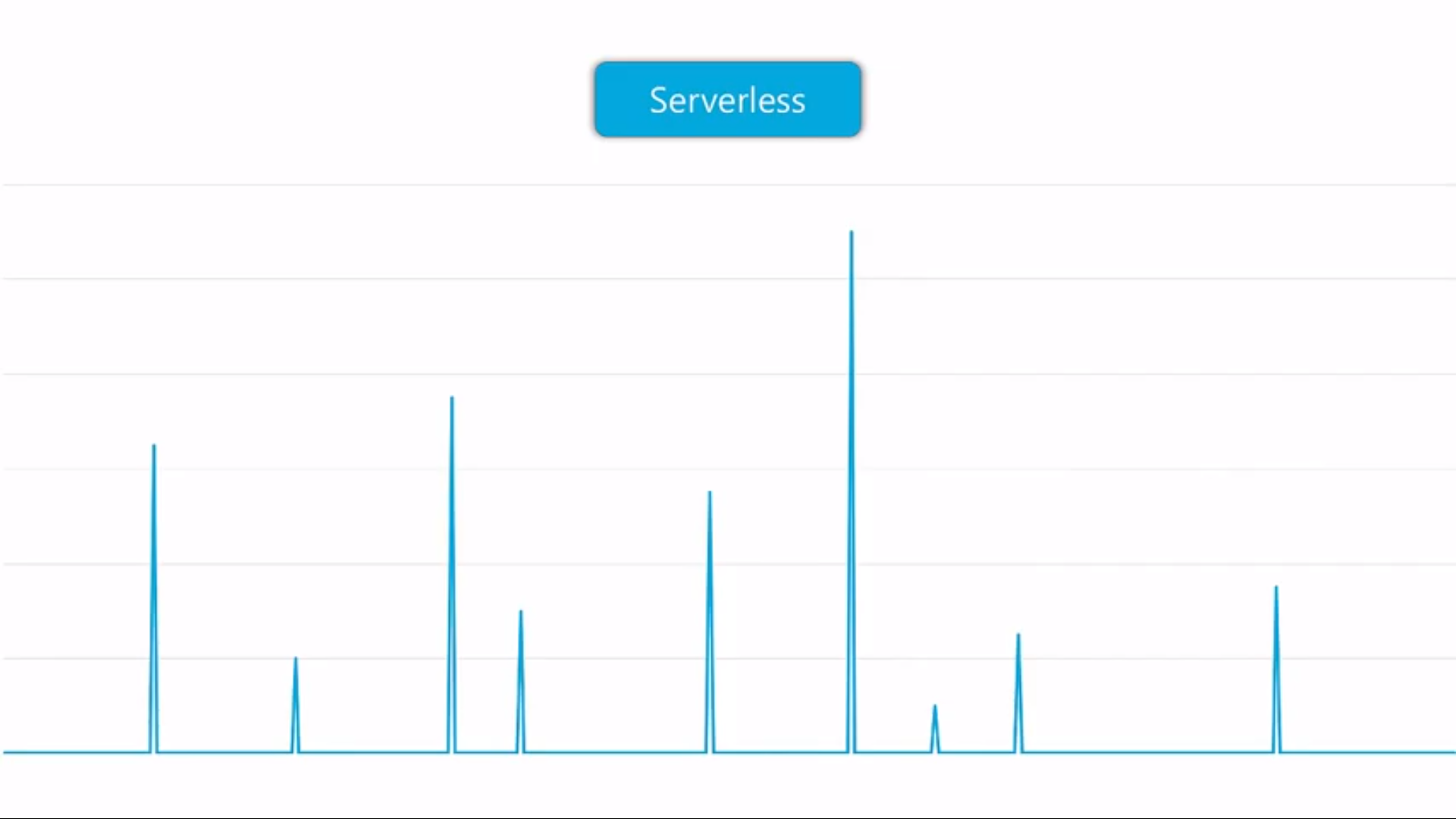

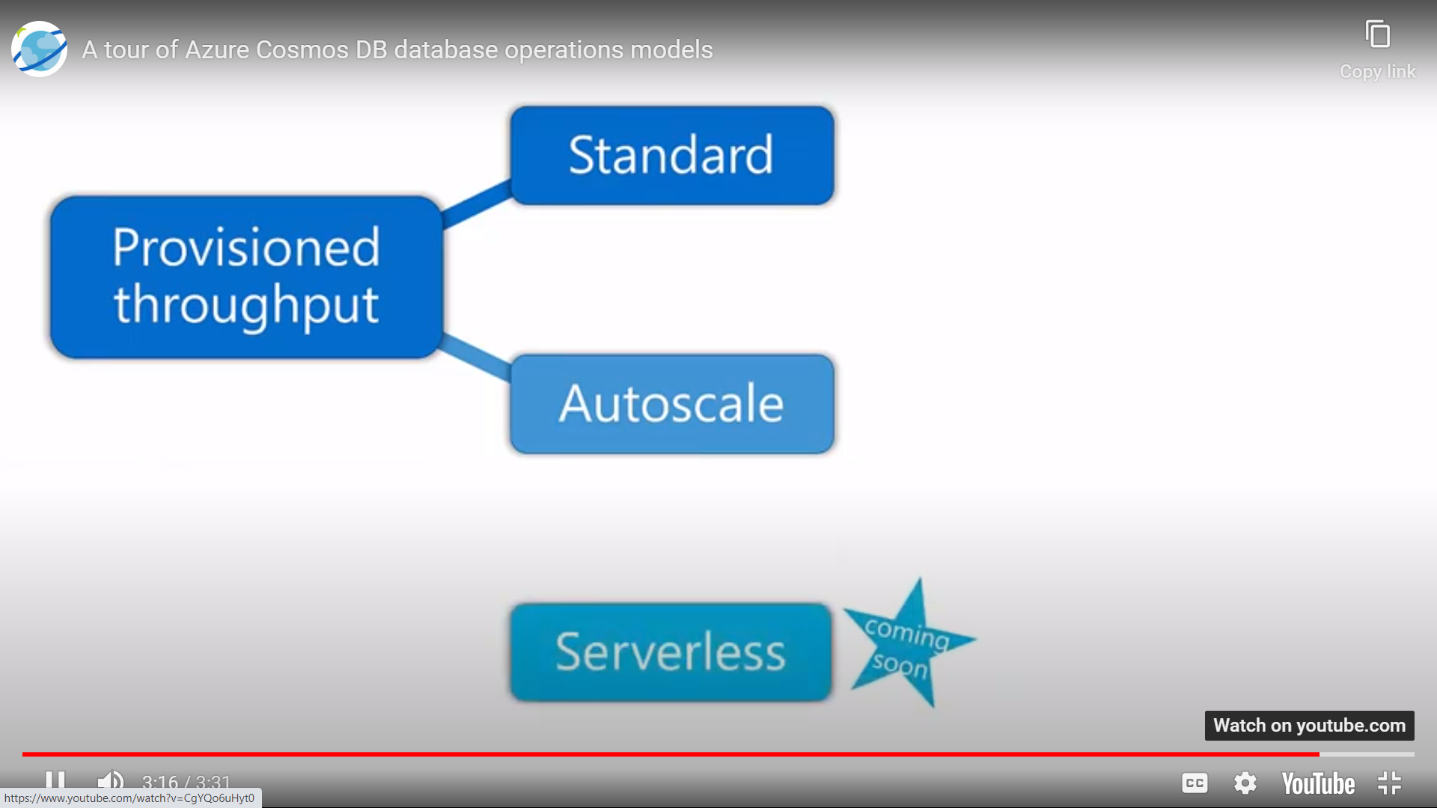

<https://docs.microsoft.com/en-us/azure/cosmos-db/throughput-serverless>

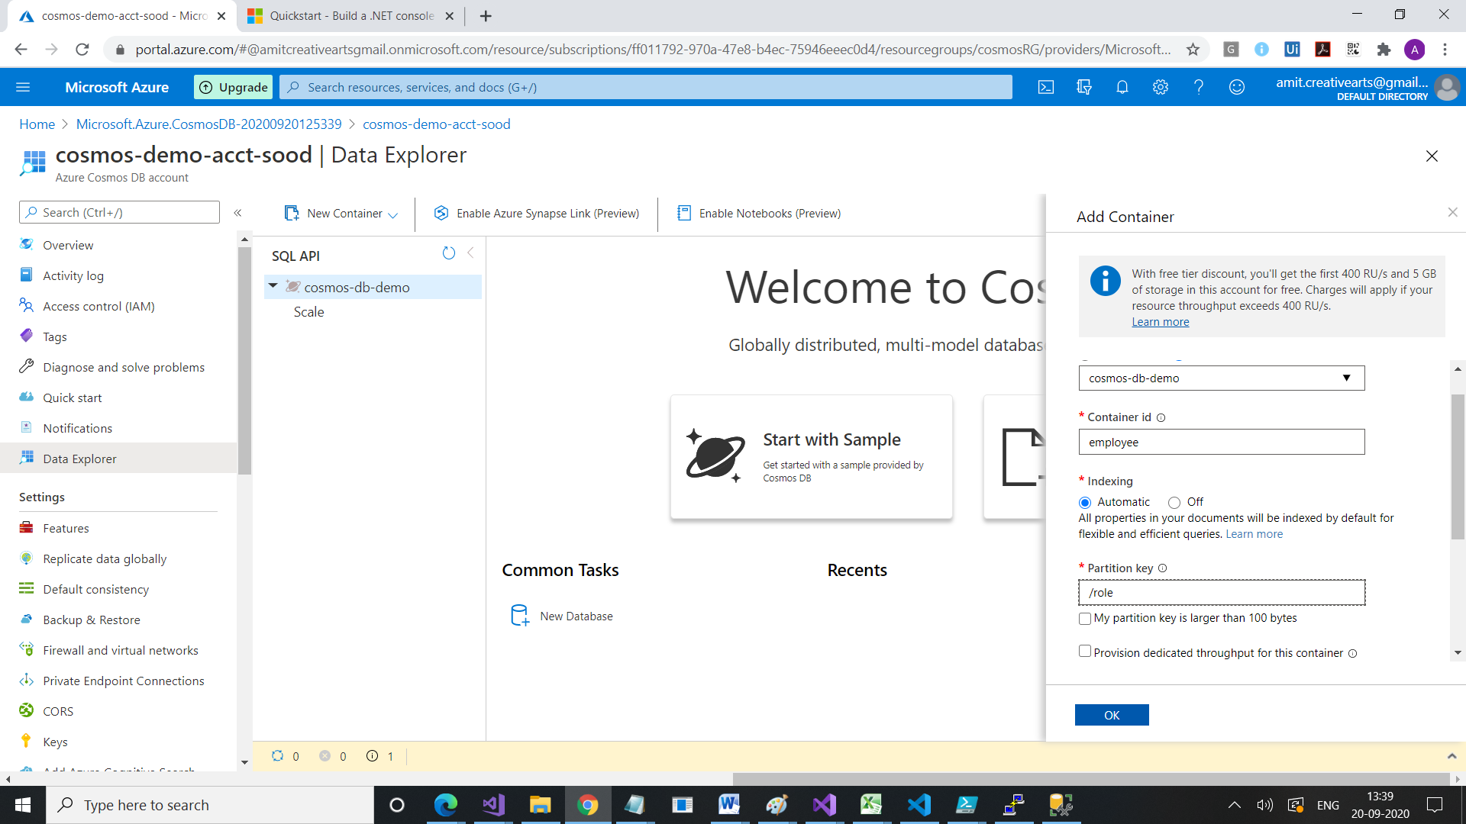

https://www.c-sharpcorner.com/article/an-overview-of-cosmos-db-start-from-scratch/

<https://stackify.com/what-is-azure-cosmos-db/>

<https://cosmos.azure.com/>

<https://docs.microsoft.com/en-us/azure/cosmos-db/create-sql-api-dotnet>

# Set variables for the new SQL API account, database, and container

resourceGroupName='myResourceGroup'

location='southcentralus'

# The Azure Cosmos account name must be globally unique, make sure to update the `mysqlapicosmosdb` value before you run the command

accountName='mysqlapicosmosdb'

# Create a resource group

az group create \

--name $resourceGroupName \

--location $location

# Create a SQL API Cosmos DB account with session consistency and multi-master enabled

az cosmosdb create \

--resource-group $resourceGroupName \

--name $accountName \

--kind GlobalDocumentDB \

--locations regionName="South Central US" failoverPriority=0 --locations regionName="North Central US" failoverPriority=1 \

--default-consistency-level "Session" \

--enable-multiple-write-locations true

Create a Cosmos Account

Comos DB is a database service that is globally distributed. It allows you to manage your data even if you keep them in data centers that are scattered throughout the world. It provides the tools you need to scale both global distribution pattern and computational resources, and these tools are provided by Microsoft Azure.

It can [support multiple data models](https://azure.microsoft.com/en-us/services/cosmos-db/) using one backend. This means that it can be used for document, key value, relational, and graph models. It is more or less a NoSQL database because it does not rely on any schemas. However, because it uses query language similar to SQL and can easily support [ACID transactions](https://en.wikipedia.org/wiki/ACID), some people have been classifying it as a NewSQL type of database. What differentiates it from other NewSQL databases, however, is that it does not have a relational data model.

### What Problem Does It Solve?

Traditionally, it would take you a long time and a lot of tedious effort to build a similar globally distributed database that you would need to host on your own data centers, using your own connections and other resources. The planning in itself would deter most companies from even thinking about such a setup; many would think that it wouldn’t be worth the investment. What happens is that most companies would rather opt out of it than take advantage of the business and growth opportunities that such a database system can offer.

When cloud computing and platform-as-a-service came along, however, it became easier to come up with a globally distributed and scalable database for your company. So easy that it is possible for just one person to architect and manage it just with a few clicks of the mouse. [Azure Cosmos DB](https://docs.microsoft.com/en-us/azure/cosmos-db/introduction) takes it to the next level, giving you a turnkey database system that you can scale according to your needs.

In sum, it will help any enterprise establish a flexible database that would help them meet their business needs. But it is especially useful for companies that are looking for a database system that is scalable and globally distributed. Globally distributed means that all resources are partitioned horizontally in every region of the world, as well as replicated across different geographical areas. That means latency is at a minimum, and your users have a faster, seamless experience. Azure Cosmos DB offers 99.99% availability.

### Additional Features

Users also get to reap the benefits of several other features including:

* **Complete service and ready to use**: It gives you a complete product that is powered by Azure and can be automatically replicated in data centers worldwide.
* **Multi-API**: Because data is indexed automatically, users can access it using any API of their choice. They can see their data using SQL, Gremlin, JavaScript, Azure Table Storage, and MongoDB.
* **A number of consistency levels**: It uses five different consistency levels: bounded staleness, strong, session, eventual, and consistent-prefix.
* **Latency**: Very low latency is practically guaranteed at less than 10 milliseconds when reading data and less than 15 milliseconds when writing data.

<https://www.c-sharpcorner.com/article/implement-stored-procedure-udfs-trigger-in-cosmos-db-using-asp-net-core-web-a/>